Entering Term FASA Scores
Grades 1-9 FASA Classes
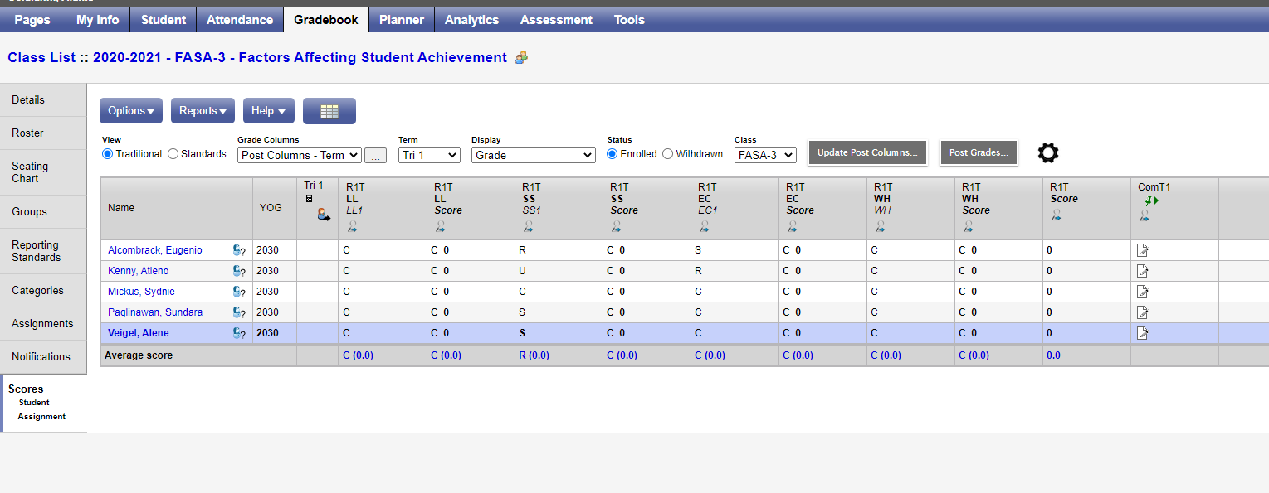
Choose Post Column - Term from the drop down
Make sure the Term drop down is correct.
Enter scores in the appropriate columns (see blue arrows). Note: Ignore the rubric marks in the Score columns.
Enter any FASA reporting period comments by clicking the icon in the associated Com section (see purple arrow)
Please consider how our 21st Century Competencies connect to FASA.
See: https://resourcebank.ca/authoring/2780-shifting-to-the-provincial-4-point-rubric/view
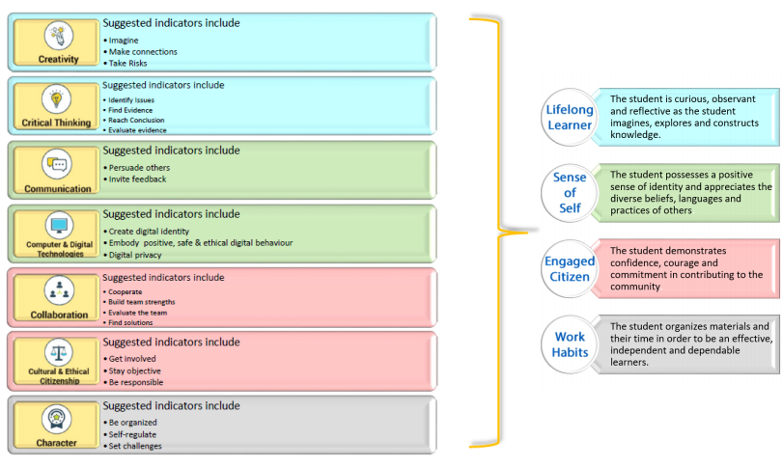

Entering Term FASA Scores
High School Classes with FASA attached
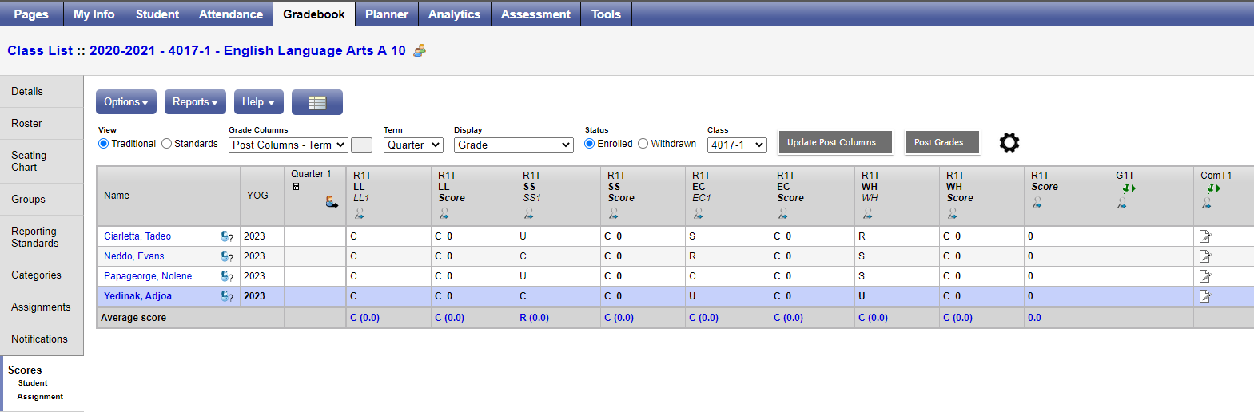

Choose Post Column – Term from the drop down
Make sure the Term drop down is correct.
Enter scores in the appropriate columns (see blue arrows). Note: Ignore the rubric marks in the Score columns.
Enter any SUBJECT specific and FASA reporting period comments by clicking the icon in the associated Com section (see purple arrow)
Please consider how our 21st Century Competencies connect to FASA.
See: https://resourcebank.ca/authoring/2780-shifting-to-the-provincial-4-point-rubric/view

