The complex task of learning to read can be split into five pillars that are displayed in the graphic below. Phonological Awareness (the ability to hear, recognize and work with the sounds in spoken language) is the foundation! On top of that, we build the foundation of phonics (the relationship between letter symbols and sounds). Once those two key pieces are in place, students can decode words, and they develop their fluency and vocabulary. The pinnacle or goal of reading is the top of the graphic which is reading comprehension!
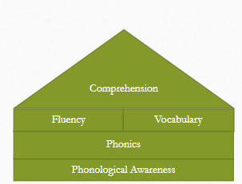
As we have this conversation about your child’s progress, this page is just a quick summary of what the various parts of the assessment mean.
The top section (turquoise) is the Quick Phonics Screener. This assessment checks the students’ knowledge of letter sounds and ability to read words of increasing complexity automatically and quickly. The stronger the students’ phonics skills are, the easier they can quickly decode words.
The middle section (purple) are word family assessments. The students are asked to quickly identify word families which are the basis of many words. The stronger they are with this skill, the better they can “chunk” unknown words into parts that they are familiar with – the word families.
The concluding section (light blue) is the PAST (Phonological Awareness Screening Test). This assessment identifies the students’ phonological awareness which is their ability to hear and manipulate sounds in words.
All these skills are combined to create strong reading skills. Each skill is rated at green: achieved, yellow: approaching achievement: or red: not achieved. Remember, for younger students, many of the red areas have not yet been assessed and may not even be applicable to your child’s grade level.
These assessments allow us to assess and see growth in foundational areas that a student may be struggling with, which leads to struggling with reading. It is also a means to celebrate growth as students progress. Your child’s personalized goal in reading will be informed by these assessments.

