The Learning Continuum - Discussion Guide
Why did we create this video?
What is the difference between blended and personalized learning?

What is the definition of Personalized Learning in Sun West?

What do we know about technology in relation to blended or personalized learning?
What does transfer of responsibility (TOR) really mean?

How can Administrators help/encourage their staff to be intentional about TOR?

List examples in your school where this is happening.

How/when might you explore the blended strategies chart with your staff?

How does the pyramid of growth relate to the learning continuum?

How could you examine the pyramid differently after watching this video?

What are the key messages in this video?

Which key messages are of greatest interest to parents and community?
Related questions for your PeBL Mentor?
What will your staff PD session regarding the
Continuum look like?
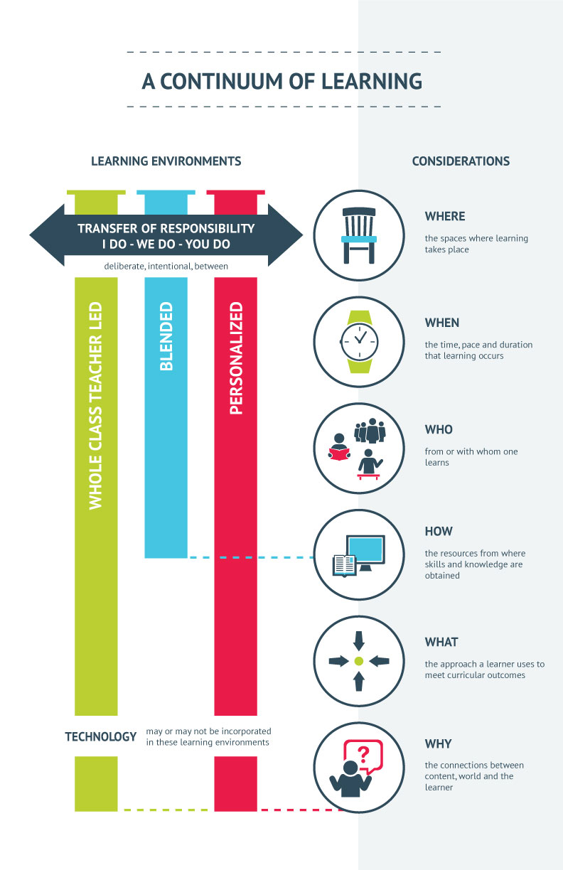

Blended Learning Strategies
 | Problem Based Learning | Inquiry Based Learning | Design Thinking | Case Based Learning | Project Based Learning
Starting Point | A problem | A question, a point of curiosity | A complex problem with human implications and unknown outcomes; no specific end in mind | An undesirable situation (case) in need of change | Multiple overlapping or related subjects or outcomes, usually the problem has multiple steps/factors
Goal | To solve problem:  find a possible or multiple possible solutions | To answer a question:  deeply explore a topic and arrive at a well-rounded answer | To design something unknown: design and test multiple solutions and identify the best outcome | To analyze and debate: provide reason for the best solution of many possible options | To create something;  Using various learning strategies and a multi-media approach to demonstrate connections between concepts
Suggested Competencies  Developed | Research skills  Collaboration  Critical thinking  Communication  Creativity  Cultural and Ethical Citizenship  Character | Research skills  Inquiry  Curiosity  Critical thinking  Communication  Creativity | Understanding of human needs  Creativity  Perseverance  Problem solving  Critical Thinking  Communication  Entrepreneurship | Analysis  Research  Reasoning  Critical thinking  Problem solving  Cultural and Ethical Citizenship | Research  Problem solving  Collaboration  Communication  Creativity  Critical Thinking
Suggestions/  Conditions | Often works well with small groups  Project Management skills are of benefit  Present the solution to an audience | Often used to explore science/math concepts, literacy and social studies | Often, but not always, used when physical/tangible solutions are anticipated.  Makerspaces are not necessary but allow for the creation and testing of physical solutions | Cases can be presented in written or video format, as simulations, games or field trips | Typically students work in groups, small or large  Students share their learning locally or globally

