Grade 2- Viewing, Listening, Speaking Choice Board
Name:___________

MUST DO:
I can view and explain the messages.  CR2.2 | I can view and explain the important details.  CR2.2 | I can view and explain the elements used (colour, layout, medium, fonts).  CR2.2
I can listen and retell the important messages and details from a small group discussion.  CR2.3 | I can listen and retell the important messages and details from a large group discussion.  CR2.3 | I can listen and follow directions told to me.  CR2.3
I can retell a story in order.  CC2.3 | I can speak clearly and give directions in order.  CC2.3 | I can speak clearly and explain information in order.  CC2.3
I can speak something I did in the order it happened.

CC2.3

Grade 2- Representing and Writing Choice Board
Name:___________

MUST DO:
Act and write a skit  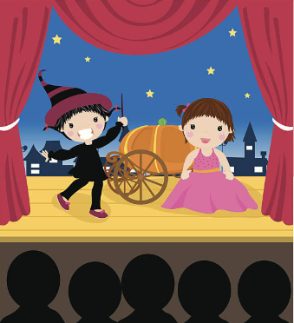  CC2.1, CC2.2, CC2.4 | Demonstration  (showing/teaching)  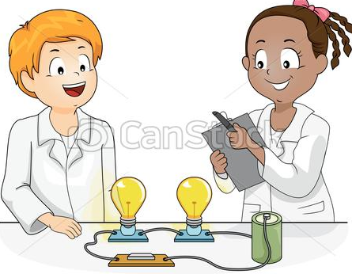  CC2.1, CC2.2 | Diagram  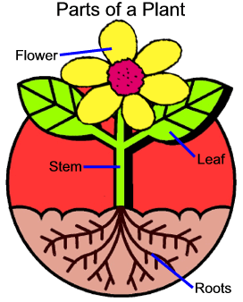  CC2.1, CC2.2
Advertisement  CC2.1, CC2.2 | Charts  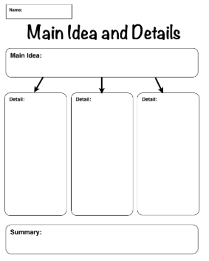  CC2.1, CC2.2 | Puppet Show  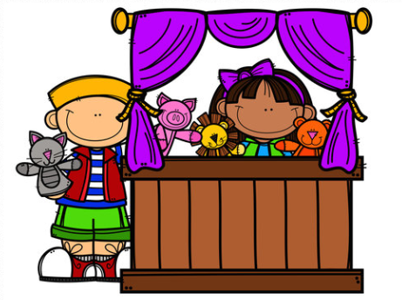  CC2.1, CC2.2
Observations  CC2.1, CC2.2, CC2.4 | Report  CC2.1, CC2.2, CC2.4

CC2.2: I can show my understanding by communicating the main ideas clearly.
CC2.4: I can write complex sentences and a paragraph (6 sentences) with clear and relevant details.

