C21-1:1 Artifact 2013-2014
Wendy Johnson, Rossville School
Grades 5, 6 & 7 - Science

I adapted this project from the link http://www.biologycorner.com/projects/biome.html

Biome Project

Introduction
A travel agency is trying to boost travel to different parts of the world by increasing the advertising and selling vacation packages. You have been hired to make a presentation to sell a travel package

Task
Working as a group, develop a short presentation to the class to sell your vacation package. Presentations can be in the form of a talk show that will be include a digital powerpoint, website or recorded aided by a green screen. You will present your talk show to the class.

Vacation Packages
taiga (coniferous forest)
tundra
tropical rain forest
desert
temperate grassland or prairie
savannah (also listed as grasslands on some sites)
temperate deciduous forest
freshwater (lakes, rivers, or streams)
ocean

Process
Each team will be assigned a biome by the teacher. It is the team's job to research the biome and gather facts and information about that biome. Each member of the team will become an expert in a particular aspect of the biome. You will research and collaborate together using OneDrive, email or other sharing/creating programs. Your powerpoints will be done using OneDrive.

Team Roles
- Botanist - this person will be an expert in the plant life of the area
- Zoologist - this person will be an expert in the animal life of the area
- Meteorologist - the weather expert, should also determine the best time of year to vacation in the biome, and what kinds of clothes to bring
- Geographer - map and area expert, will show landmarks, major cities and places a tourist should visit, or activities related to that area (climbing, scuba..etc)
Discuss with your team which role each of you will assume. Remember that you are all responsible for learning about the biome you are presenting, but your role reflects an area of particular focus for you as your research
Each team member should choose a website from the resource list and find their biome, they should record facts and information about the biome that would be useful in the presentation in OneDrive. Use a single document but you all add to it.
This OneDrive factsheet will be turned in to show that you did your share of the group work.
Remember your role. You can write down anything useful you think the team will need, but your focus should be on the role you were assigned (geographer, meteorologist, Zoologist, Botanist)
Some questions to consider:
What kinds of activities could people do in this location?
What kinds of plants and animals live there?
What kind of clothes should they bring?
What's the weather like?
What is the best time of year to to travel there?
What part of the world will they be travelling to?
Are there any dangerous elements to traveling there?
Rejoin your group and discuss your findings and develop your presentation.

Presentations
Use any of the following formats, check with your instructor for additional instructions or information:
1. A flyer that you can hand out to the class (ask your teacher to make copies). Microsoft Office has a publisher program to help make pamphlets.
2. Make a real poster on posterboard. Make a self standing project board that has pictures and information about your biome.
3. Make a presentation using powerpoint and present to the class on a digital project.
4. Create a website on weebly.com (They will do this with me if they want to use it.)

Resources
- Biomes - Missouri Botanical Gardens
http://mbgnet.mobot.org/sets/
- The World's Biomes
http://www.ucmp.berkeley.edu/glossary/gloss5/biome/
- Biomes of the World
http://www.teachersfirst.com/lessons/biomes/biomes.html
- Introduction to Biomes
http://www.runet.edu/~swoodwar/CLASSES/GEOG235/biomes/intro.html
*Also you are free to use search engines, such as google and use “for kids” at the end of your search words to locate information.
Biome Group Project
Outcome: IE 7.2 Observe, illustrate, and analyze living organisms within local ecosystems as part of interconnected food webs, populations, and communities.
I can illustrate the ecological organization of life within the biosphere. I will use a specific example of specie, population, community, ecosystem and biome.
I can examine the biotic and abiotic components of a distant ecosystem using photos, videos, or online resources
IE 7.1 Relate key aspects of Indigenous knowledge to their understanding of ecosystems.
Gather information about traditional Indigenous practices with respect to the relationships and connections between people and their ecological environment.
 | 5 | 4 | 3 | 2 | 1
Botanist | Plants are illustrated in the presentation with detail. They include more than two pictures of plants and info on them. Info included is related to each plant's value to the area. Can include harmful or dangerous plants. can also be used | Plants are illustrated in the presentation in great detail. This will include at least 2 plants and information on more than two plans. Info will be included that relates to the plant’s importance to the biome. Videos may be included. | Plants are illustrated in the presentation with detail. They include information related to that plant's value to the area. Harmful or dangerous plants can also be used | Plants are illustrated but without detail. Information is minimal. | Incomplete assignment. Not ready to present.
Zoologist | More than 3 animals will be presented in great detail in your presentation. These will be animals that would be seen while on vacation in your biome. Details of habitat and lifestyle are included. | At least 2 animals that you would see in this biome while on vacation are included in the presentation. Great detail is given throughout the presentation. Use of video may be used. Details of habitat and lifestyle are included | Animals presented in the presentation are those that you would see in the biome while on vacation. At least one picture of an animal is included, with details of the animals habitat and lifestyle. Details of habitat and lifestyle are included | No pictures or references to animals that would be seen while on vacation. A short reference to habitat and lifestyle but not grade standard. | OOPS! You didn’t do this part!
Meterologist | The biome's weather patterns are discussed in detail, seasonal changes are mentioned in detail and the audience has an excellent idea of what kinds of clothes to bring to this vacation spot. Various weather maps and weather videos are presented. | The biome's weather patterns are discussed in detail, seasonal changes are mentioned in detail and the audience has an excellent idea of what kinds of clothes to bring to this vacation spot. Weather maps and videos are present. | The biome's weather patterns are discussed, seasonal changes are mentioned and audience have an idea of what kinds of clothes to bring to this vacation spot. | The biome’s weather patterns were outlined and some seasonal changes. Not up to grade standard. Presentation is lacking in most areas. | Not up to grade standard. Hardly, if any information was given. Unprepared for class.
Geographer | A very detailed map is presented that includes a detailed legend of topography, as well as roads, towns and cities. Numerous sites are showcased and given in great detail. Pictures and videos are included. | A detailed map is included that includes a legend of topography. (hills, mountains, low lands, etc.) Numerous sites are showcased in great detail. | A map is included in the presentation with a list of "sites to see" while at the biome or location. Either many sites are briefly mentioned or one site is showcased in great detail. | A map is included in the presentation. It briefly mentions some sites. No sites are showcased. Not up to grade standard. | Something like a map is presented. Grade standard is not met. Some sites may be mentioned but nothing showcased or explained. Well below grade standard.
First Nation’s (FN) Component | Group gave a very detailed presentation on First Nations beliefs and perspectives of ecosystems. Shared pictures, videos and other materials. Very thorough presentation on what FN believe about people and biomes and their interactions. Stories, pictures, videos were shared. | Each member presented specific examples and elaborated on the First Nations beliefs and perspectives of ecosystems. Excellent research on FN perspectives & beliefs of how people interact with biomes. Pictures and videos were shared. | Each member provided specific examples of FNMI knowledge about ecosystems. An explanation of what FN people believe about the earth and how people and earth interact with one another. | First Nations content was scarce. | No First Nations content included.
Overall Presentation | Each member was very well rehearsed and organized. Presentation went very smoothly. Document, power point or webpage was creative and well organized. Students have become experts on their biome. | Each member contributed to the presentation, was well rehearsed, organized. Presentation went very smoothly. Document, power point or webpage was creative and well organized. Students are very knowledgeable. | Each member spoke and contributed to the presentation. Presentation had a smooth flow and organization is evident; Document (ppt, .doc, webpage) is creative and well organized. | Member contributions are unequal. Presentation has some bumps. Not rehearsed as well as it could have been. Some organizational problems. Documents had some flaws. | Group struggled with the group assignment. Presentation was not rehearsed enough. Bumps and organizational issues are very apparent. More work needs to be done to be successful.

Teacher comments:

This was a first effort for using this type of project. The students started with the OneDrive really well. They move away from it. It was a learning experience for us all. OneDrive seemed limited compared to using the whole Office program at the schools. They collaborated with slides and used their email to communicate and send information and links from home and to each other when they found info for a different “expert.”
Other types of technology that we used this year was Padlet.com for French, Twitter for ELA, Science and general reflections about events at school. We have started to post things on our school’s Facebook page as well.

https://twitter.com/rossville2014
https://www.facebook.com/pages/Rossville-School/272222572925582?ref_type=bookmark

Students use their 1:1 mini laptops daily each morning for Mathletics, Xtramath.org and Reading Eggs.com
Here are a few examples of some of the slides that the were made using Power point.
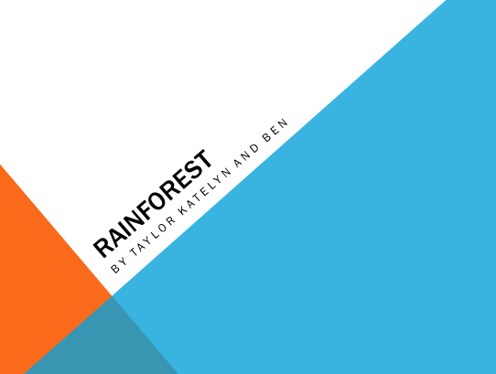
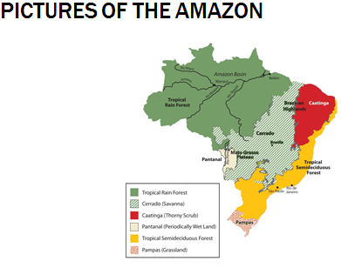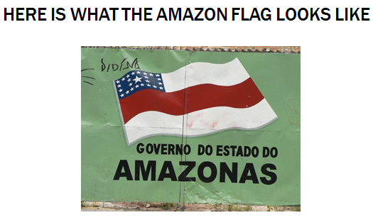

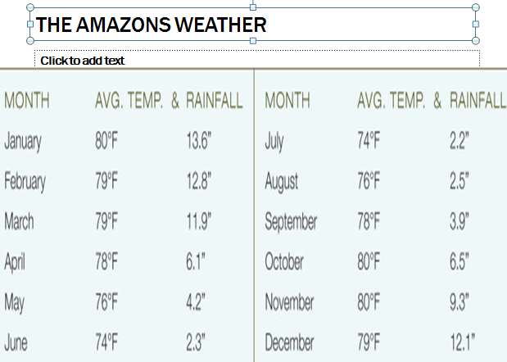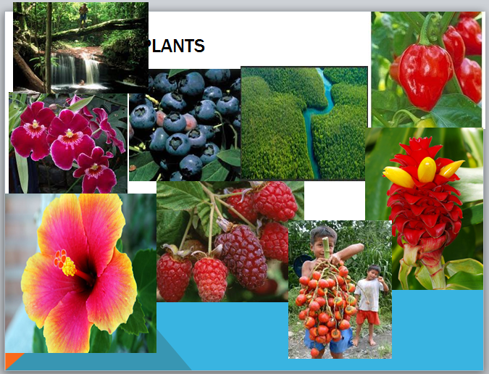
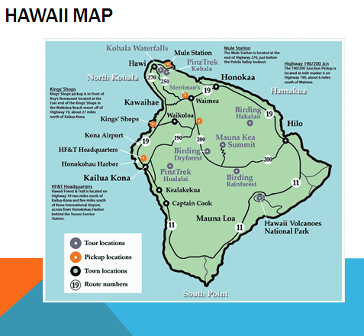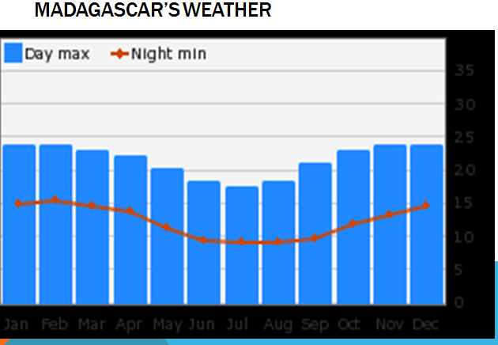

Padlet.com
