**2015-2016 21st CE Artifact: *Fun Physics Friday Activities***

**Name:** Sandra Baldwin

**School:** Davidson

**Grade/Subject:** Physics 30 or Physical Science 20 (but could be for middle years or younger)

**Outcomes:**

*Different activities connect to different outcome in Physical Science 20 and Physics 30.*

**Goal:**

*To give students a chance to use their creative and critical thinking skills in a variety of physics related challenges.*

*Students track their activities and do reflections on their own learning. (See sheet at bottom)*

**Assessment:**

Students are given the opportunity to connect to their Fun Physic Friday challenges to the curriculum goals and aims dependent on the course.

For example – this questions can be adapted to fit particular curriculum.

Listed below are 7 statements that relate to science knowledge. Use your FPF (Fun Physic Friday) activities to prove how 5 of the 7 statements were true in your experiences during the FPF challenges. Be sure to use specific examples from your own experiences to show why the statement was true for your experience.

**Statement 1:** Science is based on evidence, developed privately by individuals or groups that is shared publicly with others.

**Statement 2:** All branches of science are interrelated.

**Statement 3:** Science is based on evidence which could be obtained by other people working in a different place and at a different time under similar conditions.

**Statement 4:** Scientific knowledge is based on experimentation or observation.

**Statement 5:** Science does not make ***absolute*** predictions or explanations.

**Statement 6:** Scientific knowledge is subject to change. It does not claim to be truth in an absolute and final sense.

**Statement 7:** Scientific knowledge is a product of humankind. It involves creative imagination. The knowledge is shaped by and from concepts that are a product of culture.

Sample Challenges

**Challenge #1: Light as a feather**

<https://www.youtube.com/watch?v=QZ9InzTLNjs>

10 minutes

Four people standing, one person sitting on chair.

Four people press down on top of head, alternating hands in stack, of person on chair for count of 10.

Four people then link their hands and use index fingers to point (like a the steeple game); then using index fingers only (one on each corner of chair) lift the person with only their two fingers each.

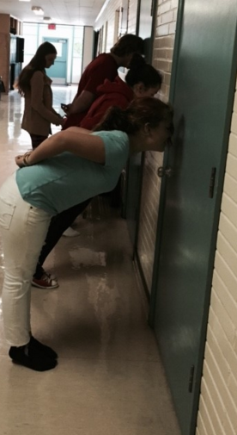**Challenge #2: Use your Head**

20 minutes

With only forehead on the wall, try to be the furthest away from the wall and then without using hands stand up from the wall. Measure the greatest distance from the wall. Set a ratio of distance from the wall to height of person.

Group with the greatest mean distance and greatest mean ratio gets top points.

**Challenge #3: Building Houses**

20 minutes

To build the highest possible structure using only a deck of playing cards and a coffee can.

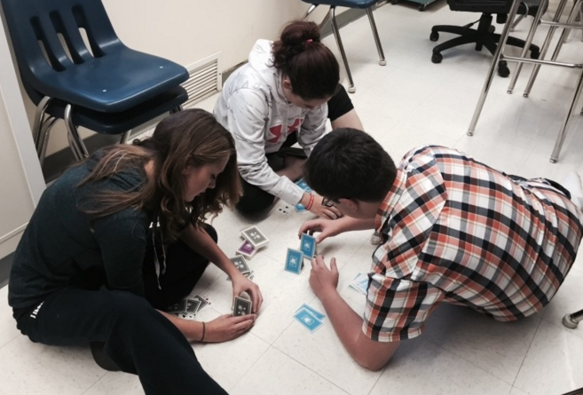

**Challenge #4: Free Standing Structures**

40 minutes

Build a free standing structure that will hold a sugar cube as great a distance as possible from a desktop. Materials: 5 pieces of paper, 100 paper clips, 10 drinking straws, and 1 metre of masking tape.

**Challenge #5: Force of Friction**

20 minutes

Take two large phone books and fold pages of books together by overlapping one page of first book with one page from second book. Try then to pull books apart.

Materials: Large phone books

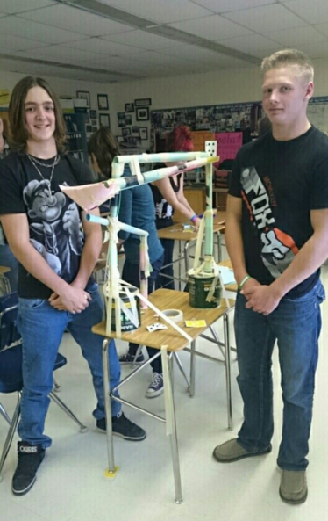**Challenge #6: Marble Mania**

40 minutes

Construct a structure starting on a desk that will carry a marble for the greatest amount of time. Materials include: two sheets of paper, 100 paper clips, 10 drinking straws, 40 pins, 25 playing cards, I metre of masking tape and one marble.

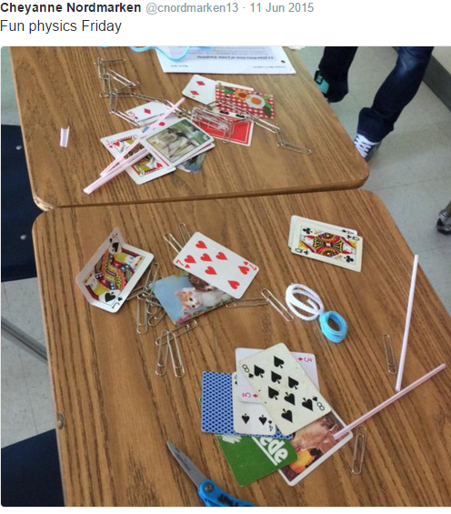

**Challenge #7: Bridge the Gap**

35 minutes

Use a newspaper to build a bridge that will span one metre and hold the largest possible mass.

Materials: newspaper, paper clips, staples, glue, scissors, objects of varying weights.

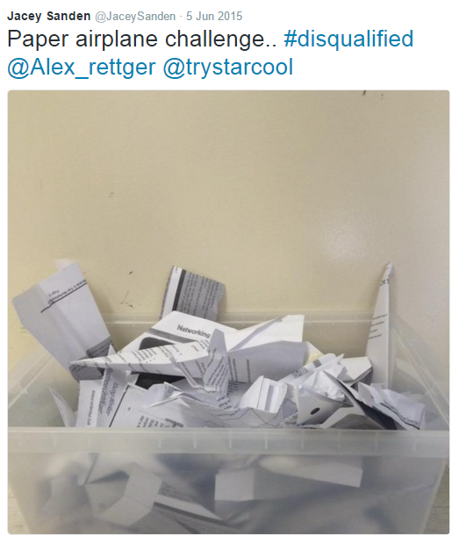

**Challenge #8: Make it Fly**

35 minutes

Make two paper ‘flyers’ that will i) take the longest time to fall to the ground from a height of 3 metres and ii) travel the furthest horizontal distance . Materials: sheets of paper, scissors, tape.

**Challenge #9: Penny Up**

10 minutes

Stack as many pennies as possible on top of bend elbow and then catch them in your hand as you straighten your arm.

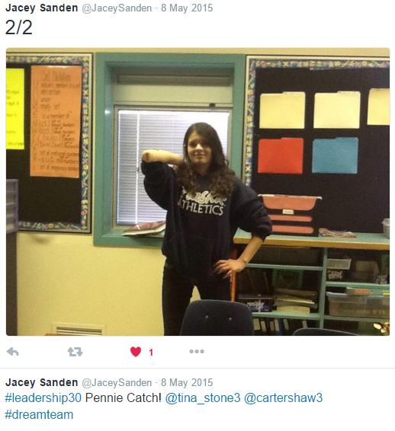

**Challenge #10: That Gravity!**

20 minutes

Figure out how to drop a slip of paper and a quarter (25 cents) from the same height at the same time so that they reach the floor at the same time.

Materials: piece of paper, a quarter, scissors.

**Challenge #11: Central Acceleration**

10 minutes

|  |  |
| --- | --- |
|  | Pail of Water whirled in a circleA pail of water is whirled in a vertical circle without spilling the water when the central acceleration is greater than or equal to the gravity. |

### **Challenge #12: Bag Bite**

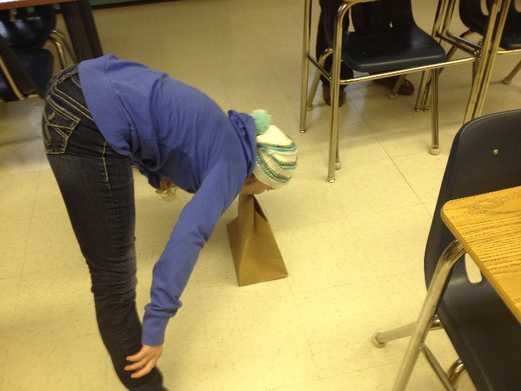**20 minutes**

**Place a paper shopping bag on the floor. Stand on one foot, bend over, and pick up the bag with your mouth. Each person has their own bag. If any part of your body other than your foot touches the ground you are out (two tries each round). One you have successfully picked up bag, cut 1 cm off the top of the bag. Continue until you have the smallest bag possible.**

**Materials:** paper bags, a pair of scissors, ruler

**Student Reflection**

5 Contributed to the group and led by making suggestions and doing the work.

4 Contributed to the group by making suggestions and by helping to do the work.

3 Contributed to the group by making suggestions but didn’t really do any of the work.

2 Contributed somewhat to the group but didn’t really know what was going on.

1 Didn’t contribute to the group and didn’t know what was going on.

0 Didn’t contribute to the group and was distracting for others.

|  |  |  |  |  |  |
| --- | --- | --- | --- | --- | --- |
| **Date** | **Location** | **Brief description of activity** | **What I accomplished** | **What I learned / connection to physics** | **Self- assessment** |
|  |  |  |  |  |  |
|  |  |  |  |  |  |
|  |  |  |  |  |  |
|  |  |  |  |  |  |