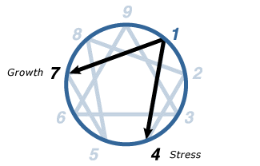
1 - THE REFORMER
Enneagram Type One

The Rational, Idealistic Type:
Principled, Purposeful, Self-Controlled, and Perfectionistic
We have named personality type One The Reformer because Ones have a “sense of mission” that leads them to want to improve the world in various ways, using whatever degree of influence they have. They strive to overcome adversity—particularly moral adversity—so that the human spirit can shine through and make a difference. They strive after “higher values,” even at the cost of great personal sacrifice.
Ones are people of practical action—they wish to be useful in the best sense of the word. On some level of consciousness, they feel that they “have a mission” to fulfill in life, if only to try their best to reduce the disorder they see in their environment.
Although Ones have a strong sense of purpose, they also typically feel that they have to justify their actions to themselves, and often to others as well. This orientation causes Ones to spend a lot of time thinking about the consequences of their actions, as well as about how to keep from acting contrary to their convictions. Because of this, Ones often persuade themselves that they are “head” types, rationalists who proceed only on logic and objective truth. But, the real picture is somewhat different: Ones are actually activists who are searching for an acceptable rationale for what they feel they must do. They are people of instinct and passion who use convictions and judgments to control and direct themselves and their actions.
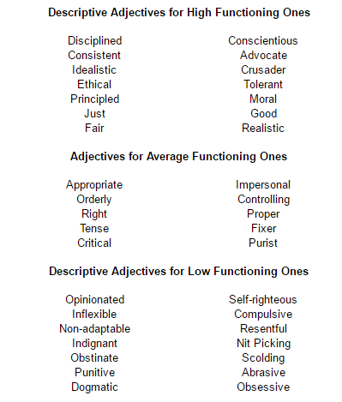

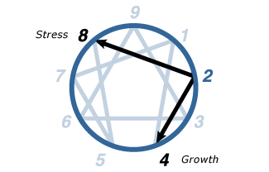
2
THE HELPER
Enneagram Type Two

The Caring, Interpersonal Type:
Generous, Demonstrative, People-Pleasing, and Possessive.
Twos are empathetic, sincere, and warm-hearted. They are friendly, generous, and self-sacrificing, but can also be sentimental, flattering, and people-pleasing. They are well-meaning and driven to be close to others, but can slip into doing things for others in order to be needed. They typically have problems with possessiveness and with acknowledging their own needs. At their Best: unselfish and altruistic, they have unconditional love for others.
We have named personality type Two The Helper because people of this type are either the most genuinely helpful to other people or, when they are less healthy they are the most highly invested in seeing themselves as helpful. Being generous and going out of their way for others makes Twos feel that theirs is the richest, most meaningful way to live. The love and concern they feel—and the genuine good they do—warms their hearts and makes them feel worthwhile. Twos are most interested in what they feel to be the “really, really good” things in life—love, closeness, sharing, family, and friendship.
When Twos are healthy and in balance, they really are loving, helpful, generous, and considerate. People are drawn to them like bees to honey. Healthy Twos warm others in the glow of their hearts. They enliven others with their appreciation and attention, helping people to see positive qualities in themselves that they had not previously recognized. In short, healthy Twos are the embodiment of “the good parent” that everyone wishes they had: someone who sees them as they are, understands them with immense compassion, helps and encourages with infinite patience, and is always willing to lend a hand—while knowing precisely how and when to let go. Healthy Twos open our hearts because theirs are already so open and they show us the way to be more deeply and richly human.
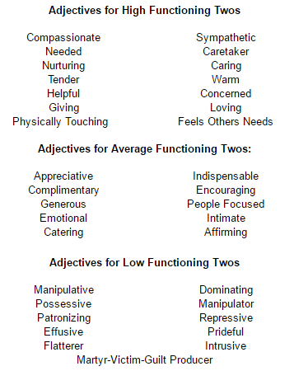

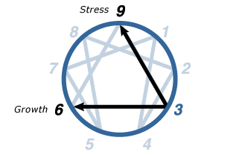
3
THE ACHIEVER
Enneagram Type Three

The Success-Oriented, Pragmatic Type:
Adaptable, Excelling, Driven, and Image-Conscious.

Threes are self-assured, attractive, and charming. Ambitious, competent, and energetic, they can also be status-conscious and highly driven for advancement. They are diplomatic and poised, but can also be overly concerned with their image and what others think of them. They typically have problems with workaholism and competitiveness. At their Best: self-accepting, authentic, everything they seem to be—role models who inspire others.
We have named personality type Three The Achiever because when they are healthy, Threes really can and do achieve great things in the world. They are the "stars" of human nature, and people often look up to them because of their graciousness and personal accomplishments. Healthy Threes know how good it feels to develop themselves and contribute their abilities to the world, and also enjoy motivating others to greater personal achievements than others thought they were capable of.
Threes are often successful and well liked because, of all the types, they most believe in themselves and in developing their talents and capacities. Threes act as living “role models” and paragons because of their extraordinary embodiment of socially valued qualities. Healthy Threes know that they are worth the effort it takes to be “the best that they can be.” Their success at doing so inspires others to invest in their own self-development.
To this end, Threes learn to perform in ways that will garner them praise and positive attention. As children, they learned to recognize the activities that were valued by their parents or peers, and put their energies into excelling in those activities. Threes also learned how to cultivate and develop whatever about them is attractive or potentially impressive.
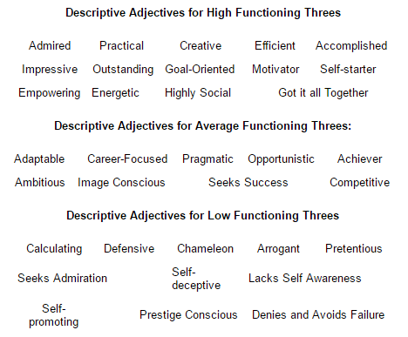

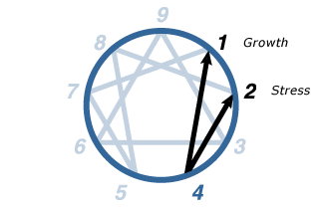
4
THE INDIVIDUALIST
Enneagram Type Four

The Sensitive, Introspective Type:
Expressive, Dramatic, Self-Absorbed, and Temperamental

Fours are self-aware, sensitive, and reserved. They are emotionally honest, creative, and personal, but can also be moody and self-conscious. Withholding themselves from others due to feeling vulnerable and defective, they can also feel disdainful and exempt from ordinary ways of living. They typically have problems with melancholy, self-indulgence, and self-pity. At their Best: inspired and highly creative, they are able to renew themselves and transform their experiences.
We have named this type The Individualist because Fours maintain their identity by seeing themselves as fundamentally different from others. Fours feel that they are unlike other human beings, and consequently, that no one can understand them or love them adequately. They often see themselves as uniquely talented, possessing special, one-of-a-kind gifts, but also as uniquely disadvantaged or flawed. More than any other type, Fours are acutely aware of and focused on their personal differences and deficiencies.
Healthy Fours are honest with themselves: they own all of their feelings and can look at their motives, contradictions, and emotional conflicts without denying or whitewashing them. They may not necessarily like what they discover, but they do not try to rationalize their states, nor do they try to hide them from themselves or others. They are not afraid to see themselves “warts and all.” Healthy Fours are willing to reveal highly personal and potentially shameful things about themselves because they are determined to understand the truth of their experience—so that they can discover who they are and come to terms with their emotional history. This ability also enables Fours to endure suffering with a quiet strength. Their familiarity with their own darker nature makes it easier for them to process painful experiences that might overwhelm other types.
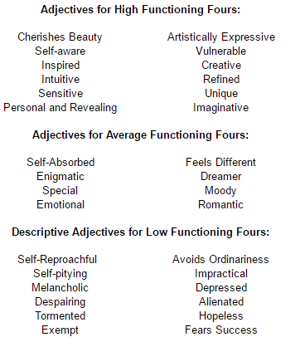

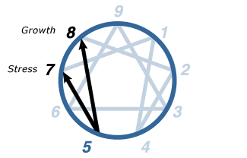
5
THE INVESTIGATOR
Enneagram Type Five

The Intense, Cerebral Type:
Perceptive, Innovative, Secretive, and Isolated

Fives are alert, insightful, and curious. They are able to concentrate and focus on developing complex ideas and skills. Independent, innovative, and inventive, they can also become preoccupied with their thoughts and imaginary constructs. They become detached, yet high-strung and intense. At their Best: visionary pioneers, often ahead of their time, and able to see the world in an entirely new way.
We have named personality type Five The Investigator because, more than any other type, Fives want to find out why things are the way they are. They want to understand how the world works, whether it is the cosmos, the microscopic world, the animal, vegetable, or mineral kingdoms—or the inner world of their imaginations. They are always searching, asking questions, and delving into things in depth. They do not accept received opinions and doctrines, feeling a strong need to test the truth of most assumptions for themselves.
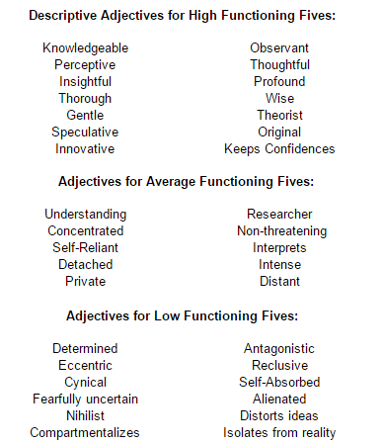

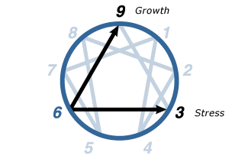
6
THE LOYALIST
Enneagram Type Six

The Committed, Security-Oriented Type:
Engaging, Responsible, Anxious, and Suspicious.

The committed, security-oriented type. Sixes are reliable, hard-working, responsible, and trustworthy. Excellent "troubleshooters," they foresee problems and foster cooperation, but can also become defensive, evasive, and anxious—running on stress while complaining about it. They can be cautious and indecisive, but also reactive, defiant and rebellious. They typically have problems with self-doubt and suspicion. At their Best: internally stable and self-reliant, courageously championing themselves and others.
We have named personality type Six The Loyalist because, of all the personality types, Sixes are the most loyal to their friends and to their beliefs. They will “go down with the ship” and hang on to relationships of all kinds far longer than most other types. Sixes are also loyal to ideas, systems, and beliefs—even to the belief that all ideas or authorities should be questioned or defied. Indeed, not all Sixes go along with the “status quo”: their beliefs may be rebellious and anti-authoritarian, even revolutionary. In any case, they will typically fight for their beliefs more fiercely than they will fight for themselves, and they will defend their community or family more tenaciously than they will defend themselves.
The reason Sixes are so loyal to others is that they do not want to be abandoned and left without support—their Basic Fear. Thus, the central issue for type Six is a failure of self-confidence. Sixes come to believe that they do not possess the internal resources to handle life’s challenges and vagaries alone, and so increasingly rely on structures, allies, beliefs, and supports outside themselves for guidance to survive. If suitable structures do not exist, they will help create and maintain them.
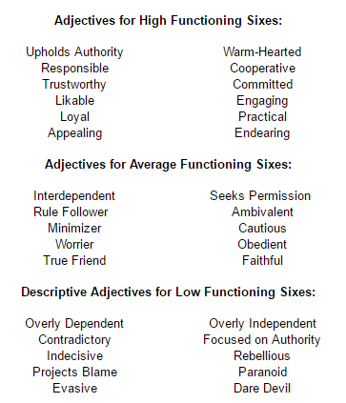

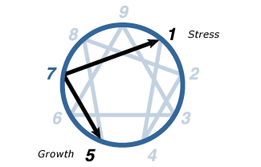
7
THE ENTHUSIAST
Enneagram Type Seven

The Busy, Variety-Seeking Type:
Spontaneous, Versatile, Acquisitive, and Scattered

Sevens are extroverted, optimistic, versatile, and spontaneous. Playful, high-spirited, and practical, they can also misapply their many talents, becoming over-extended, scattered, and undisciplined. They constantly seek new and exciting experiences, but can become distracted and exhausted by staying on the go. They typically have problems with impatience and impulsiveness. At their Best: they focus their talents on worthwhile goals, becoming appreciative, joyous, and satisfied.
We have named this personality type The Enthusiast because Sevens are enthusiastic about almost everything that catches their attention. They approach life with curiosity, optimism, and a sense of adventure, like “kids in a candy store” who look at the world in wide-eyed, rapt anticipation of all the good things they are about to experience. They are bold and vivacious, pursuing what they want in life with a cheerful determination. They have a quality best described by the Yiddish word “chutzpah”—a kind of brash “nerviness.”
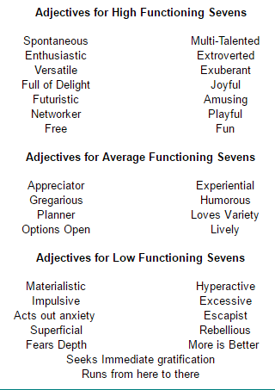
Although Sevens are in the Thinking Center, this is not immediately apparent because they tend to be extremely practical and engaged in a multitude of projects at any given time. Their thinking is anticipatory: they foresee events and generate ideas “on the fly,” favoring activities that stimulate their minds—which in turn generate more things to do and think about. Sevens are not necessarily intellectual or studious by any standard definition, although they are often intelligent and can be widely read and highly verbal. Their minds move rapidly from one idea to the next, making Sevens gifted at brainstorming and synthesizing information. Sevens are exhilarated by the rush of ideas and by the pleasure of being spontaneous, preferring broad overviews and the excitement of the initial stages of the creative process to probing a single topic in depth.

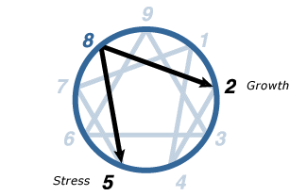
8
THE CHALLENGER
Enneagram Type Eight

The Powerful, Dominating Type:
Self-Confident, Decisive, Willful, and Confrontational.

Eights are self-confident, strong, and assertive. Protective, resourceful, straight-talking, and decisive, but can also be ego-centric and domineering. Eights feel they must control their environment, especially people, sometimes becoming confrontational and intimidating. Eights typically have problems with their tempers and with allowing themselves to be vulnerable. At their Best: self- mastering, they use their strength to improve others' lives, becoming heroic, magnanimous, and inspiring.
We have named personality type Eight The Challenger because, of all the types, Eights enjoy taking on challenges themselves as well as giving others opportunities that challenge them to exceed themselves in some way. Eights are charismatic and have the physical and psychological capacities to persuade others to follow them into all kinds of endeavors—from starting a company, to rebuilding a city, to running a household, to waging war, to making peace.
Eights have enormous willpower and vitality, and they feel most alive when they are exercising these capacities in the world. They use their abundant energy to effect changes in their environment—to “leave their mark" on it—but also to keep the environment, and especially other people, from hurting them and those they care about. At an early age, Eights understand that this requires strength, will, persistence, and endurance—qualities that they develop in themselves and which they look for in others.
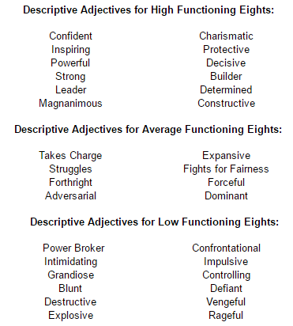

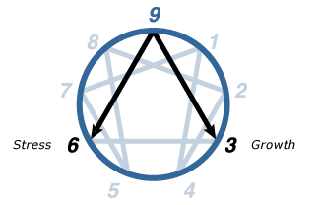
9
THE PEACEMAKER
Enneagram Type Nine

The Easygoing, Self-Effacing Type:
Receptive, Reassuring Agreeable, and Complacent

Nines are accepting, trusting, and stable. They are usually creative, optimistic, and supportive, but can also be too willing to go along with others to keep the peace. They want everything to go smoothly and be without conflict, but they can also tend to be complacent, simplifying problems and minimizing anything upsetting. They typically have problems with inertia and stubbornness. At their Best: indomitable and all-embracing, they are able to bring people together and heal conflicts.
We have called personality type Nine The Peacemaker because no type is more devoted to the quest for internal and external peace for themselves and others. They are typically “spiritual seekers” who have a great yearning for connection with the cosmos, as well as with other people. They work to maintain their peace of mind just as they work to establish peace and harmony in their world. The issues encountered in the Nine are fundamental to all psychological and spiritual work—being awake versus falling asleep to our true nature; presence versus entrancement, openness versus blockage, tension versus relaxation, peace versus pain, union versus separation.
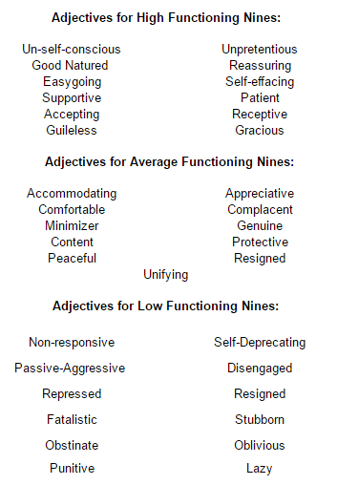
Ironically, for a type so oriented to the spiritual world, Nine is the center of the Instinctive Center, and is the type that is potentially most grounded in the physical world and in their own bodies. The contradiction is resolved when we realize that Nines are either in touch with their instinctive qualities and have tremendous elemental power and personal magnetism, or they are cut off from their instinctual strengths and can be disengaged and remote, even lightweight.

INTJ PERSONALITY (“THE ARCHITECT”)
It’s lonely at the top, and being one of the rarest and most strategically capable personality types, INTJs know this all too well. INTJs form just two percent of the population, and women of this personality type are especially rare, forming just 0.8% of the population – it is often a challenge for them to find like-minded individuals who are able to keep up with their relentless intellectualism and chess-like maneuvering. People with the INTJ personality type are imaginative yet decisive, ambitious yet private, amazingly curious, but they do not squander their energy.

Nothing Can Stop the Right Attitude From Achieving Its Goal
With a natural thirst for knowledge that shows itself early in life, INTJs are often given the title of “bookworm” as children. While this may be intended as an insult by their peers, they more than likely identify with it and are even proud of it, greatly enjoying their broad and deep body of knowledge. INTJs enjoy sharing what they know as well, confident in their mastery of their chosen subjects, but owing to their Intuitive (N) and Judging (J) traits, they prefer to design and execute a brilliant plan within their field rather than share opinions on “uninteresting” distractions like gossip.
“You are not entitled to your opinion. You are entitled to your informed opinion. No one is entitled to be ignorant.”
Harlan Ellison
A paradox to most observers, INTJs are able to live by glaring contradictions that nonetheless make perfect sense – at least from a purely rational perspective. For example, INTJs are simultaneously the most starry-eyed idealists and the bitterest of cynics, a seemingly impossible conflict. But this is because INTJ types tend to believe that with effort, intelligence and consideration, nothing is impossible, while at the same time they believe that people are too lazy, short-sighted or self-serving to actually achieve those fantastic results. Yet that cynical view of reality is unlikely to stop an interested INTJ from achieving a result they believe to be relevant.

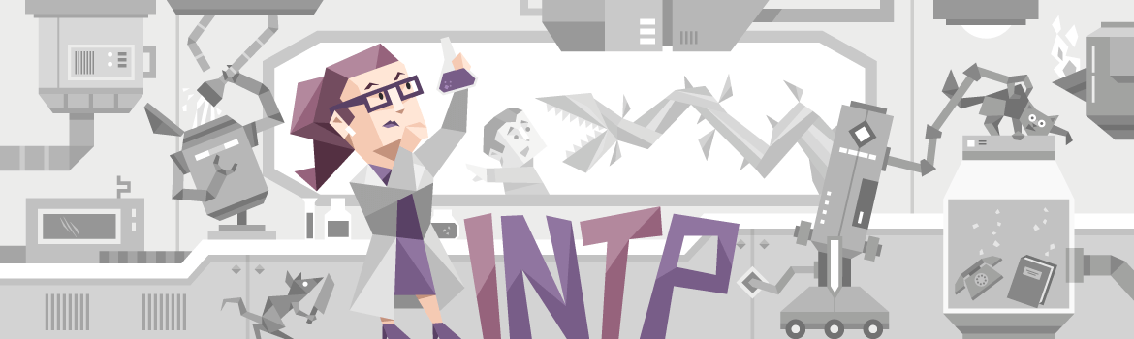

INTP PERSONALITY (“THE LOGICIAN”)
Learn from yesterday, live for today, hope for tomorrow. The important thing is not to stop questioning.
Albert Einstein
The INTP personality type is fairly rare, making up only three percent of the population, which is definitely a good thing for them, as there’s nothing they’d be more unhappy about than being "common". INTPs pride themselves on their inventiveness and creativity, their unique perspective and vigorous intellect. Usually known as the philosopher, the architect, or the dreamy professor, INTPs have been responsible for many scientific discoveries throughout history.

The Unexamined Life Is Not Worth Living
INTPs are known for their brilliant theories and unrelenting logic – in fact, they are considered the most logically precise of all the personality types.
They love patterns, and spotting discrepancies between statements could almost be described as a hobby, making it a bad idea to lie to an INTP. This makes it ironic that INTPs’ word should always be taken with a grain of salt – it’s not that they are dishonest, but people with the INTP personality type tend to share thoughts that are not fully developed, using others as a sounding board for ideas and theories in a debate against themselves rather than as actual conversation partners.
This may make them appear unreliable, but in reality no one is more enthusiastic and capable of spotting a problem, drilling through the endless factors and details that encompass the issue and developing a unique and viable solution than INTPs – just don’t expect punctual progress reports. People who share the INTP personality type aren’t interested in practical, day-to-day activities and maintenance, but when they find an environment where their creative genius and potential can be expressed, there is no limit to the time and energy INTPs will expend in developing an insightful and unbiased solution.

ENTJ PERSONALITY (“THE COMMANDER”)
Your time is limited, so don’t waste it living someone else’s life. Don’t be trapped by dogma — which is living with the results of other people’s thinking. Don’t let the noise of others’ opinions drown out your own inner voice. And most important, have the courage to follow your heart and intuition. They somehow already know what you truly want to become. Everything else is secondary.
Steve Jobs
ENTJs are natural-born leaders. People with this personality type embody the gifts of charisma and confidence, and project authority in a way that draws crowds together behind a common goal. But unlike their Feeling (F) counterpart, ENTJs are characterized by an often ruthless level of rationality, using their drive, determination and sharp minds to achieve whatever end they’ve set for themselves. Perhaps it is best that they make up only three percent of the population, lest they overwhelm the more timid and sensitive personality types that make up much of the rest of the world – but we have ENTJs to thank for many of the businesses and institutions we take for granted every day.

Happiness Lies in the Joy of Achievement
If there’s anything ENTJs love, it’s a good challenge, big or small, and they firmly believe that given enough time and resources, they can achieve any goal. This quality makes people with the ENTJ personality type brilliant entrepreneurs, and their ability to think strategically and hold a long-term focus while executing each step of their plans with determination and precision makes them powerful business leaders. This determination is often a self-fulfilling prophecy, as ENTJs push their goals through with sheer willpower where others might give up and move on, and their Extraverted (E) nature means they are likely to push everyone else right along with them, achieving spectacular results in the process.

ENTP PERSONALITY (“THE DEBATER”)
Follow the path of the unsafe, independent thinker. Expose your ideas to the dangers of controversy. Speak your mind and fear less the label of ’crack-pot’ than the stigma of conformity. And on issues that seem important to you, stand up and be counted at any cost.
Thomas J. Watson
The ENTP personality type is the ultimate devil’s advocate, thriving on the process of shredding arguments and beliefs and letting the ribbons drift in the wind for all to see. Unlike their more determined Judging (J) counterparts, ENTPs don’t do this because they are trying to achieve some deeper purpose or strategic goal, but for the simple reason that it’s fun. No one loves the process of mental sparring more than ENTPs, as it gives them a chance to exercise their effortlessly quick wit, broad accumulated knowledge base, and capacity for connecting disparate ideas to prove their points.
An odd juxtaposition arises with ENTPs, as they are uncompromisingly honest, but will argue tirelessly for something they don’t actually believe in, stepping into another’s shoes to argue a truth from another perspective.
Playing the devil’s advocate helps people with the ENTP personality type to not only develop a better sense of others’ reasoning, but a better understanding of opposing ideas – since ENTPs are the ones arguing them.
This tactic shouldn’t be confused with the sort of mutual understanding Diplomats seek – ENTPs, like all Analyst personality types, are on a constant quest for knowledge, and what better way to gain it than to attack and defend an idea, from every angle, from every side?

INFJ PERSONALITY (“THE ADVOCATE”)
The INFJ personality type is very rare, making up less than one percent of the population, but they nonetheless leave their mark on the world. As Diplomats, they have an inborn sense of idealism and morality, but what sets them apart is the accompanying Judging (J) trait – INFJs are not idle dreamers, but people capable of taking concrete steps to realize their goals and make a lasting positive impact.
INFJs tend to see helping others as their purpose in life, but while people with this personality type can be found engaging rescue efforts and doing charity work, their real passion is to get to the heart of the issue so that people need not be rescued at all.

Help Me Help You
INFJs indeed share a unique combination of traits: though soft-spoken, they have very strong opinions and will fight tirelessly for an idea they believe in. They are decisive and strong-willed, but will rarely use that energy for personal gain – INFJs will act with creativity, imagination, conviction and sensitivity not to create advantage, but to create balance. Egalitarianism and karma are very attractive ideas to INFJs, and they tend to believe that nothing would help the world so much as using love and compassion to soften the hearts of tyrants.
Every man must decide whether he will walk in the light of creative altruism or in the darkness of destructive selfishness.
Martin Luther King
INFJs find it easy to make connections with others, and have a talent for warm, sensitive language, speaking in human terms, rather than with pure logic and fact. It makes sense that their friends and colleagues will come to think of them as quiet Extraverted types, but they would all do well to remember that INFJs need time alone to decompress and recharge, and to not become too alarmed when they suddenly withdraw. INFJs take great care of other’s feelings, and they expect the favor to be returned – sometimes that means giving them the space they need for a few days.

INFP PERSONALITY (“THE MEDIATOR”)
INFP personalities are true idealists, always looking for the hint of good in even the worst of people and events, searching for ways to make things better. While they may be perceived as calm, reserved, or even shy, INFPs have an inner flame and passion that can truly shine. Comprising just 4% of the population, the risk of feeling misunderstood is unfortunately high for the INFP personality type – but when they find like-minded people to spend their time with, the harmony they feel will be a fountain of joy and inspiration.
Being a part of the Diplomat personality group, INFPs are guided by their principles, rather than by logic (Analysts), excitement (Explorers), or practicality (Sentinels). When deciding how to move forward, they will look to honor, beauty, morality and virtue – INFPs are led by the purity of their intent, not rewards and punishments. People who share the INFP personality type are proud of this quality, and rightly so, but not everyone understands the drive behind these feelings, and it can lead to isolation.

We Know What We Are, but Know Not What We May Be
At their best, these qualities enable INFPs to communicate deeply with others, easily speaking in metaphors and parables, and understanding and creating symbols to share their ideas. The strength of this intuitive communication style lends itself well to creative works, and it comes as no surprise that many famous INFPs are poets, writers and actors. Understanding themselves and their place in the world is important to INFPs, and they explore these ideas by projecting themselves into their work.
INFPs have a talent for self-expression, revealing their beauty and their secrets through metaphors and fictional characters.

ENFJ PERSONALITY (“THE PROTAGONIST”)
Everything you do right now ripples outward and affects everyone. Your posture can shine your heart or transmit anxiety. Your breath can radiate love or muddy the room in depression. Your glance can awaken joy. Your words can inspire freedom. Your every act can open hearts and minds.
David Deida
ENFJs are natural-born leaders, full of passion and charisma. Forming around two percent of the population, they are oftentimes our politicians, our coaches and our teachers, reaching out and inspiring others to achieve and to do good in the world. With a natural confidence that begets influence, ENFJs take a great deal of pride and joy in guiding others to work together to improve themselves and their community.

Firm Believers in the People
People are drawn to strong personalities, and ENFJs radiate authenticity, concern and altruism, unafraid to stand up and speak when they feel something needs to be said. They find it natural and easy to communicate with others, especially in person, and their Intuitive (N) trait helps people with the ENFJ personality type to reach every mind, be it through facts and logic or raw emotion. ENFJs easily see people’s motivations and seemingly disconnected events, and are able to bring these ideas together and communicate them as a common goal with an eloquence that is nothing short of mesmerizing.
The interest ENFJs have in others is genuine, almost to a fault – when they believe in someone, they can become too involved in the other person’s problems, place too much trust in them. Luckily, this trust tends to be a self-fulfilling prophecy, as ENFJs’ altruism and authenticity inspire those they care about to become better themselves. But if they aren’t careful, they can overextend their optimism, sometimes pushing others further than they’re ready or willing to go.
ENFJs are genuine, caring people who talk the talk and walk the walk, and nothing makes them happier than leading the charge, uniting and motivating their team with infectious enthusiasm.

ENFP PERSONALITY (“THE CAMPAIGNER”)
It doesn’t interest me what you do for a living. I want to know what you ache for – and if you dare to dream of meeting your heart’s longing. It doesn’t interest me how old you are. I want to know if you will risk looking like a fool – for love – for your dreams – for the adventure of being alive.
Oriah Mountain Dreamer
The ENFP personality is a true free spirit. They are often the life of the party, but unlike Explorers, they are less interested in the sheer excitement and pleasure of the moment than they are in enjoying the social and emotional connections they make with others. Charming, independent, energetic and compassionate, the 7% of the population that they comprise can certainly be felt in any crowd.

You Can Change the World With Just an Idea
More than just sociable people-pleasers though, ENFPs, like all their Diplomat cousins, are shaped by their Intuitive (N) quality, allowing them to read between the lines with curiosity and energy. They tend to see life as a big, complex puzzle where everything is connected – but unlike Analysts, who tend to see that puzzle as a series of systemic machinations, ENFPs see it through a prism of emotion, compassion and mysticism, and are always looking for a deeper meaning.
ENFPs are fiercely independent, and much more than stability and security, they crave creativity and freedom.

ISTJ PERSONALITY (“THE LOGISTICIAN”)
My observation is that whenever one person is found adequate to the discharge of a duty... it is worse executed by two persons, and scarcely done at all if three or more are employed therein.
George Washington
The ISTJ personality type is thought to be the most abundant, making up around 13% of the population. Their defining characteristics of integrity, practical logic and tireless dedication to duty make ISTJs a vital core to many families, as well as organizations that uphold traditions, rules and standards, such as law offices, regulatory bodies and military. People with the ISTJ personality type enjoy taking responsibility for their actions, and take pride in the work they do – when working towards a goal, ISTJs hold back none of their time and energy completing each relevant task with accuracy and patience.

ISTJs don’t make many assumptions, preferring instead to analyze their surroundings, check their facts and arrive at practical courses of action. ISTJ personalities are no-nonsense, and when they’ve made a decision, they will relay the facts necessary to achieve their goal, expecting others to grasp the situation immediately and take action. ISTJs have little tolerance for indecisiveness, but lose patience even more quickly if their chosen course is challenged with impractical theories, especially if they ignore key details – if challenges becomes time-consuming debates, ISTJs can become noticeably angry as deadlines tick nearer.

ISFJ PERSONALITY (“THE DEFENDER”)
Love only grows by sharing. You can only have more for yourself by giving it away to others.
Brian Tracy
The ISFJ personality type is quite unique, as many of their qualities defy the definition of their individual traits. Though possessing the Feeling (F) trait, ISFJs have excellent analytical abilities; though Introverted (I), they have well-developed people skills and robust social relationships; and though they are a Judging (J) type, ISFJs are often receptive to change and new ideas. As with so many things, people with the ISFJ personality type are more than the sum of their parts, and it is the way they use these strengths that defines who they are.
ISFJs are true altruists, meeting kindness with kindness-in-excess and engaging the work and people they believe in with enthusiasm and generosity.
There’s hardly a better type to make up such a large proportion of the population, nearly 13%. Combining the best of tradition and the desire to do good, ISFJs are found in lines of work with a sense of history behind them, such as medicine, academics and charitable social work.
ISFJ personalities (especially Turbulent ones) are often meticulous to the point of perfectionism, and though they procrastinate, they can always be relied on to get the job done on time. ISFJs take their responsibilities personally, consistently going above and beyond, doing everything they can to exceed expectations and delight others, at work and at home.

ESTJ PERSONALITY (“THE EXECUTIVE”)
ESTJs are representatives of tradition and order, utilizing their understanding of what is right, wrong and socially acceptable to bring families and communities together. Embracing the values of honesty, dedication and dignity, people with the ESTJ personality type are valued for their clear advice and guidance, and they happily lead the way on difficult paths. Taking pride in bringing people together, ESTJs often take on roles as community organizers, working hard to bring everyone together in celebration of cherished local events, or in defense of the traditional values that hold families and communities together.
ESTJs are aware of their surroundings and live in a world of clear, verifiable facts – the surety of their knowledge means that even against heavy resistance, they stick to their principles and push an unclouded vision of what is and is not acceptable. Their opinions aren’t just empty talk either, as ESTJs are more than willing to dive into the most challenging projects, improving action plans and sorting details along the way, making even the most complicated tasks seem easy and approachable.
However, ESTJs don’t work alone, and they expect their reliability and work ethic to be reciprocated – people with this personality type meet their promises, and if partners or subordinates jeopardize them through incompetence or laziness, or worse still, dishonesty, they do not hesitate to show their wrath. This can earn them a reputation for inflexibility, a trait shared by all Sentinels, but it’s not because ESTJs are arbitrarily stubborn, but because they truly believe that these values are what make society work.
ESTJs are classic images of the model citizen: they help their neighbors, uphold the law, and try to make sure that everyone participates in the communities and organizations they hold so dear.

ESFJ PERSONALITY (“THE CONSUL”)
Encourage, lift and strengthen one another. For the positive energy spread to one will be felt by us all.
Deborah Day
People who share the ESFJ personality type are, for lack of a better word, popular – which makes sense, given that it is also a very common personality type, making up twelve percent of the population. In high school, ESFJs are the cheerleaders and the quarterbacks, setting the tone, taking the spotlight and leading their teams forward to victory and fame. Later in life, ESFJs continue to enjoy supporting their friends and loved ones, organizing social gatherings and doing their best to make sure everyone is happy.
At their hearts, ESFJ personalities are social creatures, and thrive on staying up to date with what their friends are doing.

Discussing scientific theories or debating European politics isn’t likely to capture ESFJs’ interest for too long. ESFJs are more concerned with fashion and their appearance, their social status and the standings of other people. Practical matters and gossip are their bread and butter, but ESFJs do their best to use their powers for good.

ISTP PERSONALITY (“THE VIRTUOSO”)
ISTPs love to explore with their hands and their eyes, touching and examining the world around them with cool rationalism and spirited curiosity. People with this personality type are natural Makers, moving from project to project, building the useful and the superfluous for the fun of it, and learning from their environment as they go. Often mechanics and engineers, ISTPs find no greater joy than in getting their hands dirty pulling things apart and putting them back together, just a little bit better than they were before.
ISTPs explore ideas through creating, troubleshooting, trial and error and first-hand experience. They enjoy having other people take an interest in their projects and sometimes don’t even mind them getting into their space. Of course, that’s on the condition that those people don’t interfere with ISTPs’ principles and freedom, and they’ll need to be open to ISTPs returning the interest in kind.
ISTPs enjoy lending a hand and sharing their experience, especially with the people they care about, and it’s a shame they’re so uncommon, making up only about five percent of the population. ISTP women are especially rare, and the typical gender roles that society tends to expect can be a poor fit – they’ll often be seen as tomboys from a young age.

Dare to Differ
While their mechanical tendencies can make them appear simple at a glance, ISTPs are actually quite enigmatic. Friendly but very private, calm but suddenly spontaneous, extremely curious but unable to stay focused on formal studies, ISTP personalities can be a challenge to predict, even by their friends and loved ones. ISTPs can seem very loyal and steady for a while, but they tend to build up a store of impulsive energy that explodes without warning, taking their interests in bold new directions.
Rather than some sort of vision quest though, ISTPs are merely exploring the viability of a new interest when they make these seismic shifts.

ISFP PERSONALITY (“THE ADVENTURER”)
ISFP personality types are true artists, but not necessarily in the typical sense where they’re out painting happy little trees. Often enough though, they are perfectly capable of this. Rather, it’s that they use aesthetics, design and even their choices and actions to push the limits of social convention. ISFPs enjoy upsetting traditional expectations with experiments in beauty and behavior – chances are, they’ve expressed more than once the phrase "Don’t box me in!"

Happy to Be Who They Are
ISFPs live in a colorful world, inspired by connections with people and ideas. ISFP personalities take joy in reinterpreting these connections, reinventing and experimenting with both themselves and new perspectives. No other type explores and experiments in this way more. This creates a sense of spontaneity, making ISFPs seem unpredictable, even to their close friends and loved ones.
Despite all this, ISFPs are definitely Introverts (I), surprising their friends further when they step out of the spotlight to be by themselves to recharge. Just because they are alone though, doesn’t mean people with the ISFP personality type sit idle – they take this time for introspection, assessing their principles. Rather than dwelling on the past or the future, ISFPs think about who they are. They return from their cloister, transformed.
ISFPs live to find ways to push their passions. Riskier behaviors like gambling and extreme sports are more common with this personality type than with others. Fortunately their attunement to the moment and their environment allows them to do better than most. ISFPs also enjoy connecting with others, and have a certain irresistible charm.
ISFPs always know just the compliment to soften a heart that’s getting ready to call their risks irresponsible or reckless.

ESTP PERSONALITY (“THE ENTREPRENEUR”)
ESTP personality types always have an impact on their immediate surroundings – the best way to spot them at a party is to look for the whirling eddy of people flitting about them as they move from group to group. Laughing and entertaining with a blunt and earthy humor, ESTP personalities love to be the center of attention. If an audience member is asked to come on stage, ESTPs volunteer – or volunteer a shy friend.
ESTPs keep their conversation energetic, with a good dose of intelligence, but they like to talk about what is – or better yet, to just go out and do it. ESTPs leap before they look, fixing their mistakes as they go, rather than sitting idle, preparing contingencies and escape clauses.

Never Confuse Movement With Action
ESTPs are the likeliest personality type to make a lifestyle of risky behavior. They live in the moment and dive into the action – they are the eye of the storm. People with the ESTP personality type enjoy drama, passion, and pleasure, not for emotional thrills, but because it’s so stimulating to their logical minds.
This makes school and other highly organized environments a challenge for ESTPs. It certainly isn’t because they aren’t smart, and they can do well, but the regimented, lecturing approach of formal education is just so far from the hands-on learning that ESTPs enjoy.
Also challenging is that to ESTPs, it makes more sense to use their own moral compass than someone else’s. Rules were made to be broken.
Sometimes ESTPs’ instantaneous observation and action is just what’s required, as in some corporate environments, and especially in emergencies.

ESFP PERSONALITY (“THE ENTERTAINER”)
If anyone is to be found spontaneously breaking into song and dance, it is the ESFP personality type. ESFPs get caught up in the excitement of the moment, and want everyone else to feel that way, too. No other personality type is as generous with their time and energy as ESFPs when it comes to encouraging others, and no other personality type does it with such irresistible style.

We Are All of Us Stars...
Born entertainers, ESFPs love the spotlight, but all the world’s a stage. Many famous people with the ESFP personality type are indeed actors, but they love putting on a show for their friends too, chatting with a unique and earthy wit, soaking up attention and making every outing feel a bit like a party. Utterly social, ESFPs enjoy the simplest things, and there’s no greater joy for them than just having fun with a good group of friends.
Though it may not always seem like it, ESFPs know that it’s not all about them – they are observant, and very sensitive to others’ emotions. People with this personality type are often the first to help someone talk out a challenging problem, happily providing emotional support and practical advice. However, if the problem is about them, ESFPs are more likely to avoid a conflict altogether than to address it head-on. ESFPs usually love a little drama and passion, but not so much when they are the focus of the criticisms it can bring.

...And We Deserve to Twinkle
The biggest challenge ESFPs face is that they are often so focused on immediate pleasures that they neglect the duties and responsibilities that make those luxuries possible. Complex analysis, repetitive tasks, and matching statistics to real consequences are not easy activities for ESFPs.
There’s nothing that makes ESFPs feel quite as unhappy as realizing that they are boxed in by circumstance, unable to join their friends
