 | Form 110-2  ESSP Level 3 School Strategic Plan  PeBL REORDER Template | School Name |  | School Year
 |  | Upload to School Based Admin Group by September 30th (Initial Plan) and Year End

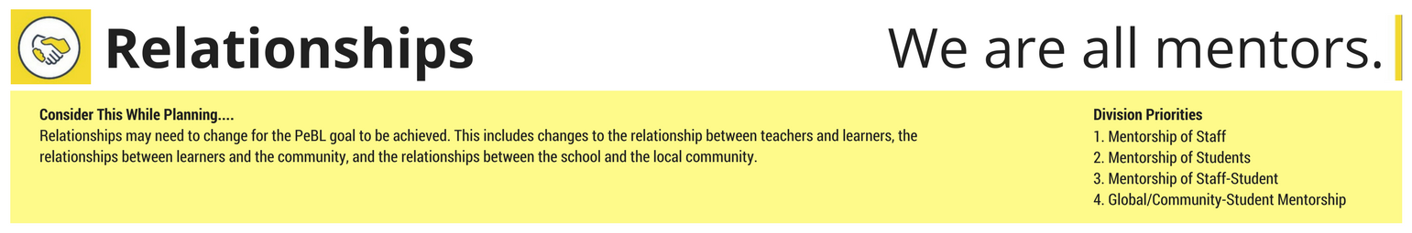
Focus Areas | Actions | Deliverables | Lead/Resource | Start Date | End Date | ESSP Connections
All learners (staff and students) will begin building learner profiles. | Click or tap here to enter text. | Click or tap here to enter text. | Click or tap here to enter text. | Click or tap to enter a date. | Click or tap to enter a date. | ☐ Early Years  ☐ Engagement  ☐ First Nations & Metis  ☐ At Grade Level  ☐ Graduation Rates  ☐ Efficiencies
Establish a staff/student mentorship plan where every student has an adult advocate in the school purposefully assigned to them. | Click or tap here to enter text. | Click or tap here to enter text. | Click or tap here to enter text. | Click or tap to enter a date. | Click or tap to enter a date. | ☐ Early Years  ☐ Engagement  ☐ First Nations & Metis  ☐ At Grade Level  ☐ Graduation Rates  ☐ Efficiencies
Create opportunities for student-to-student mentoring in their learning environments. | Click or tap here to enter text. | Click or tap here to enter text. | Click or tap here to enter text. | Click or tap to enter a date. | Click or tap to enter a date. | ☐ Early Years  ☐ Engagement  ☐ First Nations & Metis  ☐ At Grade Level  ☐ Graduation Rates  ☐ Efficiencies
Create opportunities for global/community members to mentor students in and out of the school. | Click or tap here to enter text. | Click or tap here to enter text. | Click or tap here to enter text. | Click or tap to enter a date. | Click or tap to enter a date. | ☐ Early Years  ☐ Engagement  ☐ First Nations & Metis  ☐ At Grade Level  ☐ Graduation Rates  ☐ Efficiencies
Other | Click or tap here to enter text. | Click or tap here to enter text. | Click or tap here to enter text. | Click or tap to enter a date. | Click or tap to enter a date. | ☐ Early Years  ☐ Engagement  ☐ First Nations & Metis  ☐ At Grade Level  ☐ Graduation Rates  ☐ Efficiencies
Adapted from www.reordereducation.com
 | Form 110-2  ESSP Level 3 School Strategic Plan  PeBL REORDER Template | School Name |  | School Year
 |  | Upload to School Based Admin Group by September 30th (Initial Plan) and Year End

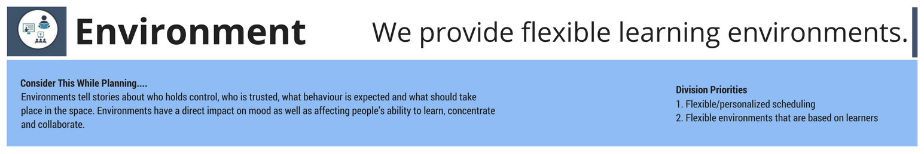
Focus Areas | Actions | Deliverables | Lead/Resource | Start Date | End Date | ESSP Connections
When planning for replacement of furniture, creating PeBL spaces will be a priority. | Click or tap here to enter text. | Click or tap here to enter text. | Click or tap here to enter text. | Click or tap to enter a date. | Click or tap to enter a date. | ☐ Early Years  ☐ Engagement  ☐ First Nations & Metis  ☐ At Grade Level  ☐ Graduation Rates  ☐ Efficiencies
Administrators and teachers will consider the impact of student voice and learning profiles on learner spaces and schedules. | Click or tap here to enter text. | Click or tap here to enter text. | Click or tap here to enter text. | Click or tap to enter a date. | Click or tap to enter a date. | ☐ Early Years  ☐ Engagement  ☐ First Nations & Metis  ☐ At Grade Level  ☐ Graduation Rates  ☐ Efficiencies
Other | Click or tap here to enter text. | Click or tap here to enter text. | Click or tap here to enter text. | Click or tap to enter a date. | Click or tap to enter a date. | ☐ Early Years  ☐ Engagement  ☐ First Nations & Metis  ☐ At Grade Level  ☐ Graduation Rates  ☐ Efficiencies
Adapted from www.reordereducation.com
 | Form 110-2  ESSP Level 3 School Strategic Plan  PeBL REORDER Template | School Name |  | School Year
 |  | Upload to School Based Admin Group by September 30th (Initial Plan) and Year End

Focus Areas | Actions | Deliverables | Lead/Resource | Start Date | End Date | ESSP Connections
The school has a plan to be actively engaged in the “I do, We do, You do” process (the continuum of transfer of responsibility), honouring student voice and choice and intentionally creating opportunities for learners to embody the 21st Century Competencies. | Click or tap here to enter text. | Click or tap here to enter text. | Click or tap here to enter text. | Click or tap to enter a date. | Click or tap to enter a date. | ☐ Early Years  ☐ Engagement  ☐ First Nations & Metis  ☐ At Grade Level  ☐ Graduation Rates  ☐ Efficiencies
Reading – Students will demonstrate skills and knowledge at or beyond grade level  DRA Grades 1-5  Reading Assessments Grade 7 & 10 | Click or tap here to enter text. | Click or tap here to enter text. | Click or tap here to enter text. | Click or tap to enter a date. | Click or tap to enter a date. | ☐ Early Years  ☐ Engagement  ☐ First Nations & Metis  ☐ At Grade Level  ☐ Graduation Rates  ☐ Efficiencies
Writing – Students will demonstration skills and knowledge at or beyond grade level  data collection Grade 4, 7, 9 | Click or tap here to enter text. | Click or tap here to enter text. | Click or tap here to enter text. | Click or tap to enter a date. | Click or tap to enter a date. | ☐ Early Years  ☐ Engagement  ☐ First Nations & Metis  ☐ At Grade Level  ☐ Graduation Rates  ☐ Efficiencies
Math - Students will demonstration skills and knowledge at or beyond grade level Data collection in Grades 2, 5, 8. | Click or tap here to enter text. | Click or tap here to enter text. | Click or tap here to enter text. | Click or tap to enter a date. | Click or tap to enter a date. | ☐ Early Years  ☐ Engagement  ☐ First Nations & Metis  ☐ At Grade Level  ☐ Graduation Rates  ☐ Efficiencies
Other | Click or tap here to enter text. | Click or tap here to enter text. | Click or tap here to enter text. | Click or tap to enter a date. | Click or tap to enter a date. | ☐ Early Years  ☐ Engagement  ☐ First Nations & Metis  ☐ At Grade Level  ☐ Graduation Rates  ☐ Efficiencies
Adapted from www.reordereducation.com
 | Form 110-2  ESSP Level 3 School Strategic Plan  PeBL REORDER Template | School Name |  | School Year
 |  | Upload to School Based Admin Group by September 30th (Initial Plan) and Year End

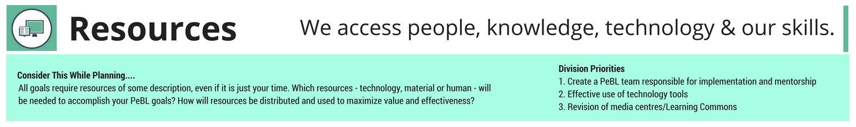
Focus Areas | Actions | Deliverables | Lead/Resource | Start Date | End Date | ESSP Connections
Schools will begin/continue to reorganize shared school spaces (ie: media centres, libraries, learning commons) to accommodate 21st century learning. | Click or tap here to enter text. | Click or tap here to enter text. | Click or tap here to enter text. | Click or tap to enter a date. | Click or tap to enter a date. | ☐ Early Years  ☐ Engagement  ☐ First Nations & Metis  ☐ At Grade Level  ☐ Graduation Rates  ☐ Efficiencies
Other | Click or tap here to enter text. | Click or tap here to enter text. | Click or tap here to enter text. | Click or tap to enter a date. | Click or tap to enter a date. | ☐ Early Years  ☐ Engagement  ☐ First Nations & Metis  ☐ At Grade Level  ☐ Graduation Rates  ☐ Efficiencies
Adapted from www.reordereducation.com
 | Form 110-2  ESSP Level 3 School Strategic Plan  PeBL REORDER Template | School Name |  | School Year
 |  | Upload to School Based Admin Group by September 30th (Initial Plan) and Year End

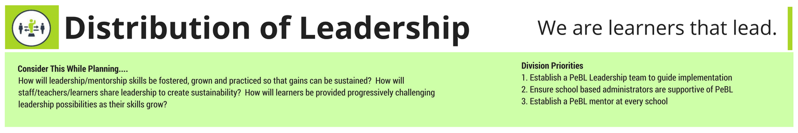
Focus Areas | Actions | Deliverables | Lead/Resource | Start Date | End Date | ESSP Connections
Administrator works as a team with PeBL Mentors, Student Support Teachers and teachers to support the needs of all learners. | Click or tap here to enter text. | Click or tap here to enter text. | Click or tap here to enter text. | Click or tap to enter a date. | Click or tap to enter a date. | ☐ Early Years  ☐ Engagement  ☐ First Nations & Metis  ☐ At Grade Level  ☐ Graduation Rates  ☐ Efficiencies
Administrator together with staff develop a communication plan for sharing PeBL with their local stakeholders (using resources provided by PeBL Leadership Team). | Click or tap here to enter text. | Click or tap here to enter text. | Click or tap here to enter text. | Click or tap to enter a date. | Click or tap to enter a date. | ☐ Early Years  ☐ Engagement  ☐ First Nations & Metis  ☐ At Grade Level  ☐ Graduation Rates  ☐ Efficiencies
Leadership opportunities will be created for all learners. | Click or tap here to enter text. | Click or tap here to enter text. | Click or tap here to enter text. | Click or tap to enter a date. | Click or tap to enter a date. | ☐ Early Years  ☐ Engagement  ☐ First Nations & Metis  ☐ At Grade Level  ☐ Graduation Rates  ☐ Efficiencies
Other | Click or tap here to enter text. | Click or tap here to enter text. | Click or tap here to enter text. | Click or tap to enter a date. | Click or tap to enter a date. | ☐ Early Years  ☐ Engagement  ☐ First Nations & Metis  ☐ At Grade Level  ☐ Graduation Rates  ☐ Efficiencies
Adapted from www.reordereducation.com

 | Form 110-2  ESSP Level 3 School Strategic Plan  PeBL REORDER Template | School Name |  | School Year
 |  | Upload to School Based Admin Group by September 30th (Initial Plan) and Year End

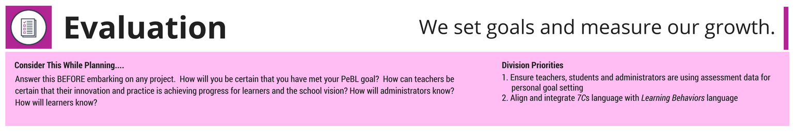
Focus Areas | Actions | Deliverables | Lead/Resource | Start Date | End Date | ESSP Connections
Re-evaluate progress/goals using the modified Flourishing Schools Inventory. | Click or tap here to enter text. | Click or tap here to enter text. | Click or tap here to enter text. | Click or tap to enter a date. | Click or tap to enter a date. | ☐ Early Years  ☐ Engagement  ☐ First Nations & Metis  ☐ At Grade Level  ☐ Graduation Rates  ☐ Efficiencies
Implement REORDER Rubric to set goals/priorities. | Click or tap here to enter text. | Click or tap here to enter text. | Click or tap here to enter text. | Click or tap to enter a date. | Click or tap to enter a date. | ☐ Early Years  ☐ Engagement  ☐ First Nations & Metis  ☐ At Grade Level  ☐ Graduation Rates  ☐ Efficiencies
Implement 21st Century Competencis Rubrics for tracking/reporting. | Click or tap here to enter text. | Click or tap here to enter text. | Click or tap here to enter text. | Click or tap to enter a date. | Click or tap to enter a date. | ☐ Early Years  ☐ Engagement  ☐ First Nations & Metis  ☐ At Grade Level  ☐ Graduation Rates  ☐ Efficiencies
Other | Click or tap here to enter text. | Click or tap here to enter text. | Click or tap here to enter text. | Click or tap to enter a date. | Click or tap to enter a date. | ☐ Early Years  ☐ Engagement  ☐ First Nations & Metis  ☐ At Grade Level  ☐ Graduation Rates  ☐ Efficiencies
Adapted from www.reordereducation.com
 | Form 110-2  ESSP Level 3 School Strategic Plan  PeBL REORDER Template | School Name |  | School Year
 |  | Upload to School Based Admin Group by September 30th (Initial Plan) and Year End

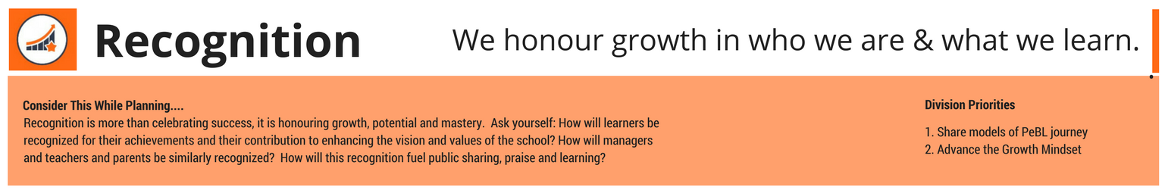
Focus Areas | Actions | Deliverables | Lead/Resource | Start Date | End Date | ESSP Connections
Actively recognize/celebrate – in verbal and/or written form – the PeBL related journey in your learning environment with all stakeholders. | Click or tap here to enter text. | Click or tap here to enter text. | Click or tap here to enter text. | Click or tap to enter a date. | Click or tap to enter a date. | ☐ Early Years  ☐ Engagement  ☐ First Nations & Metis  ☐ At Grade Level  ☐ Graduation Rates  ☐ Efficiencies
Re-envision the “recognition culture” in the school and align it with a growth mindset philosophy. | Click or tap here to enter text. | Click or tap here to enter text. | Click or tap here to enter text. | Click or tap to enter a date. | Click or tap to enter a date. | ☐ Early Years  ☐ Engagement  ☐ First Nations & Metis  ☐ At Grade Level  ☐ Graduation Rates  ☐ Efficiencies
Other | Click or tap here to enter text. | Click or tap here to enter text. | Click or tap here to enter text. | Click or tap to enter a date. | Click or tap to enter a date. | ☐ Early Years  ☐ Engagement  ☐ First Nations & Metis  ☐ At Grade Level  ☐ Graduation Rates  ☐ Efficiencies
Adapted from www.reordereducation.com

 | Form 110-2  ESSP Level 3 School Strategic Plan  PeBL REORDER Template | School Name |  | School Year
 |  | Upload to School Based Admin Group by September 30th (Initial Plan) and Year End

Priority School Learning Improvement Goal
1. Current state and the reason for action. (Explain what the problem is and why strategic action is required to address it.) | 4. Implementation Plan (What are the high-level actions that will be taken to address the problem within the given timeframe? How will the future state be achieved?)  Actions Deliverables Lead Start Date Completion Date—Place check mark and date completed Status if more time is needed Resources Required (Human and Financial)
2. Cause (What is causing the problem and what evidence can be provided to support the analysis? Provide data and analysis.)

3. Improvement Goal (State goal. How will the situation will be different because of the actions taken to improve it?) | 5. Metrics (How will you know there has been an improvement? Identify outcome and process metrics that will indicate the project success These should relate to the actions noted above in the implementation plan. Identify measures that are anticipated to change monthly.) | Engagement How will students, parents, and stakeholders, etc., be engaged in this work? Name any target groups required for success.)

