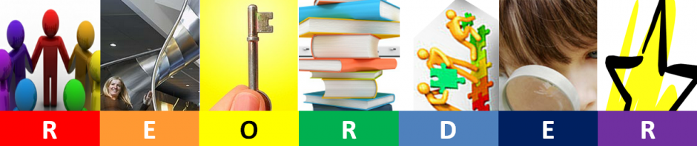
Overview of REORDER
In brief, the REORDER framework states that for a larger goal or vision to be realized it must take account of all of the following aspects.
Relationships
Environments
Opportunities
Resources
Distribution of leadership
Evaluation
Recognition

Relationships
Description: Relationships may need to change for the PeBL goal to be achieved. This includes changes to …
- The relationship between teachers and learners.
- The relationships between learners and the community
- The relationships between the school and the local community
Environments
Description: Environments tell stories about who holds control, who is trusted, what behaviour is expected and what should take place in the space. Environments have a direct impact on mood as well as affecting people’s ability to learn, concentrate and collaborate.
Opportunities
Description: Which curriculum structures and learning opportunities will be used to build the skills needed for the PeBL goal to become a reality? How will freedom of pathways, personalization, choice of pace or content be achieved through these opportunities? How do you ensure that the competencies, skills and attitudes for successful lifelong thinking and learning are integrated meaningfully into all opportunities with clear progression of challenge?
Resources
Description: All goals require resources of some description, even if it is just your time. Which technology resources, human resources and materials will be needed for the PeBL goals you are considering? How will the resources be distributed and used effectively to maximize the value gained from them and help you achieve your goals?

Distribution of Leadership
Description: How will leadership/mentorship skills be fostered, grown and practiced so that gains can be sustained? How will staff/teachers/learners share leadership to create sustainability? How will learners be provided progressively challenging leadership possibilities as their skills grow?
Evaluation
Description: How will you be certain that you have met your PeBL goal? It is critical that this is considered BEFORE embarking on any project because it is important to know what progress has been made as a result of you achieving your goals. Throughout the school, how can teachers be certain that their innovation and practice is achieving progress for learners and the school vision? How will administrators know? How will learners know?
Recognition
Recognition is more than celebrating success, it is honouring growth, potential and mastery.
Some key questions to consider may be:
- How will learners be recognized for their achievements and their contribution to enhancing the vision and values of the school?
- How will administrators and teachers and parents be similarly recognized?
- How will this recognition fuel public sharing, praise and learning?
- Many school goals are based on competencies such as student ability to reflect the 7 C’s – how will progression in these goals be measured, recognized and rewarded?
- How can IT and teachers manage e-portfolios of evidence?
- Will peer recognition be given status in terms of peer review and peer assessment?
- How will the skills of students be recognized if they are higher than those of the teacher? (IE Technology)
- How will the introduction of new teaching practices and successful development be recognized and qualified?

