Planning & Assessment Best Practices
Planning:
Start with the end in mind:
  - Understanding by Design: The Backward Design Model (UBD)
  - “To begin with the end in mind means to start with a clear understanding of your destination. It means to know where you’re going so that you better understand where you are now so that the steps you take are always in the right direction.” (Covey, 1994)
  - Together with your students, know what outcomes need to be covered. Think about what your students should Know, Understand, and Be Able to Do (KUD)
  - Together with your students, plan learning experiences that will help your students achieve those outcomes.
  - See Appendix for Planning with the End visual.
  - See Appendix for Nine Events of Instruction.

Unpack the Outcomes:
- Together with your students, break down the learning outcomes so that students have a clear picture of what they need to know, understand, and be able to do.
- Together with your students write outcomes in student-friendly language so that they know where they are headed with their learning (example: “I Can” statements).
- Use the “I Can” statements in the classroom so that students has a visual reminder of what is to be taught and learned (example: on the classrooms walls, personal learning plan, portfolios, OneNote, etc).
- See Appendix for “Think Aloud for Unpacking Outcomes” and “Steps for Unpacking Outcomes and Indicators”.
Develop Learning Experiences
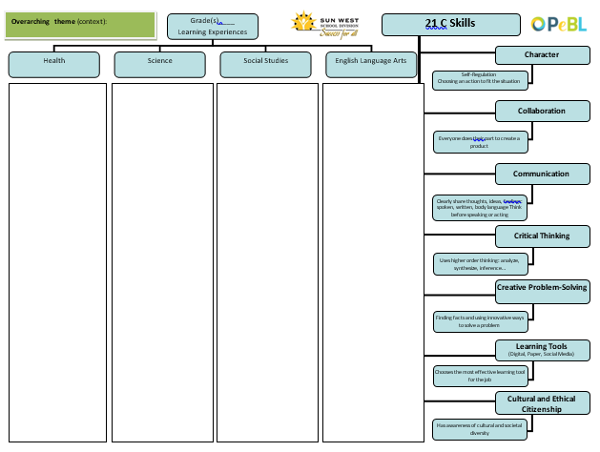
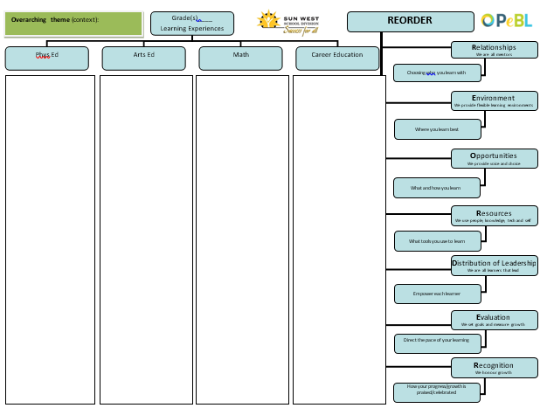
Consider utilizing cross-curricular planning when developing learning experiences, while keeping in mind the 7 C’s and REORDER (See Appendix for Cross-Curricular Planning Template)

Develop Unit Plans
When planning for units of study/ learning experiences, there are many things to consider:
- big ideas/key questions/essential understandings
- outcomes
- assessment plan
- instructional strategies and activities
- methods of inquiry
- ways to differentiate to need individual student needs
- opportunities for personalization
- materials/resources.
- Ways to incorporate the 7 C’s and REORDER
During each step of the planning process, consider the movement back and forth of the transfer of responsibility (I Do, We Do, You Do)
- See Appendix for Learning Experiences/Unit Planning Template

Develop Lesson Plans

Based on the 1) outcomes outlined in your learning experiences/unit plan, 2) the timeline that you have developed for how your year will look, and 3) the pre-assessment you have done – create learning experiences that assist students in meeting curricular outcomes, that allow personalized voice, choice, path, place and pace.
- See Appendix for Lesson Planning Template

Considerations when planning learning experiences

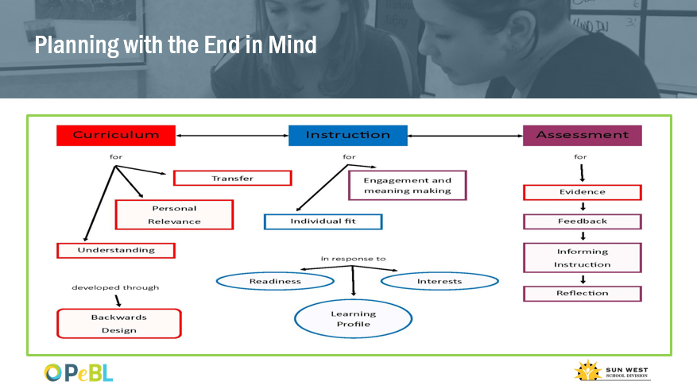
Planning with the End in Mind

Nine Events of Instruction

This list of suggested teaching strategies is to assist teachers in the development of learning experiences with their students is adapted from Gagne’s Nine Universal Steps of Instruction.

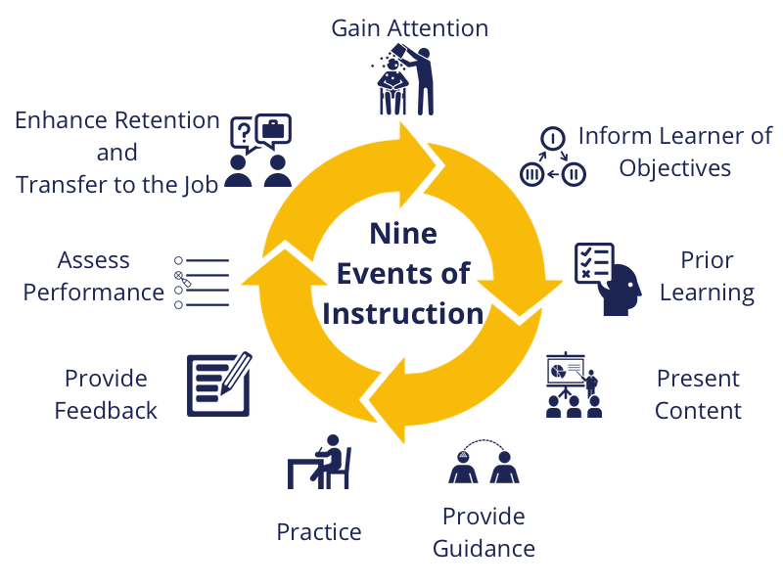

Strategies
- Gain Attention & Motivate the Learner
- Inform the learner of the outcomes/Explain What is to be Learned
- Recall Previous Knowledge/ Prior Learning
- Present the Material to be Learned
- Provide Guidance for Learning
- Active Involvement/ Practice and Interactive with Content
- Provide Feedback ( Formative)
- Assessment Performance ( Summative)
- Provide Enrichment, Enhance Retention, Transfer of Responsibility
Think aloud for unpacking outcomes
Before You Start:
- read the outcome very carefully
- think about what the outcome is asking students to know and be able to do.
Step 1:
- focus on the verb in the outcome. The verb gives the HOW of the outcome – the skill that the student will be able to do
- circle the verb
Step 2:
- look for the nouns in the outcome – what the students need to know
- underline all of the nouns in the outcome – now you know the WHAT of the outcome
Step 3:
- fill in the “Knowledge” and “Skills” part of the chart
Step 4:
- think about how the outcome could be rewritten in “student friendly” language – something they can understand
- these are the “I Can” statements that teachers post in the classroom to give the students a visual reminder of what the goal for the learning is
Step 5:
- think about what you would assess for the outcome – specific knowledge and skills – what they know and are able to do
- think about how you would do that assessment – there is a vast array of assessment strategies that could be used

STEPS FOR UNPACKING THE OUTCOMES AND INDICATORS
Outcome:

Steps for unpacking each outcome:
- Underline the nouns in the outcome; they are the Knowledge that students should know.
- Circle the verbs in the outcome; they are the Skills that the students should know.
- List them in the boxes under Knowledge and Skills

KNOWLEDGE  (what student should know)  Nouns | SKILLS  (what student should be able to do)  Verbs

- Rewrite the outcome in language the student will understand:

- What specific knowledge and skills from the unpacked outcomes would you assess? By what methods?

Character
Collaboration
Communication
Critical Thinking
Creative Problem-Solving

Learning Tools
(Digital, Paper, Social Media)

Self-Regulation
Choosing an action to fit the situation

Everyone does their part to create a product
Clearly share thoughts, ideas, feelings: spoken, written, body language Think before speaking or acting
Uses higher order thinking: analyze, synthesize, inference…
Finding facts and using innovative ways to solve a problem
Chooses the most effective learning tool for the job
Has awareness of cultural and societal diversity
Cultural and Ethical Citizenship

Overarching theme (context):

21 C Skills
Grade(s)____
Learning Experiences
Health
Science
Social Studies
English Language Arts

Relationships
We are all mentors
Environment
We provide flexible learning environments
Opportunities
We provide voice and choice
Resources
We use people, knowledge, tech and self
Distribution of Leadership
We are all learners that lead
Evaluation
We set goals and measure growth
Choosing who you learn with
Where you learn best
What and how you learn
What tools you use to learn
Empower each learner
Direct the pace of your learning
How your progress/growth is praised/celebrated
Recognition
We honour growth
Overarching theme (context):

REORDER
Grade(s)____
Learning Experiences
Phys Ed
Arts Ed
Math
Career Education

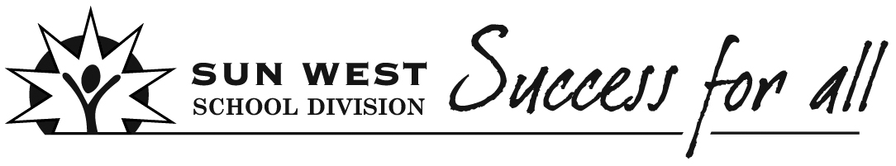
Learning Experiences (Unit) Planning
Teacher(s) | Subject(s) |  | Grade |  | Date  Timeline
Big Ideas/Key Questions/Essential Understandings
Create a Big Idea to guide the Learning Experience
I do | We do | You do
Teacher looks at outcomes and decides the Big Idea for the Learning Experience. | Teacher and students work together to come up with the Big Idea. | Teacher provides students with outcomes and students come up with the Big Idea.
Big Idea(s)

Outcomes
I do | We do | You do
Teachers use the Curriculum document to select specific outcomes that address the Learning Experience. | Teachers and students look at the Curriculum outcomes or I can statements together and select specific outcomes that address the Learning Experience. | Teacher shows students the curriculum outcomes or I can statements and students lead the way in deciding the specific outcomes that address the Learning Experience.
(Consider unpacking some of the outcomes with your students.)
Selected Outcomes

Assessment Plan
I do | We do | You do
Teacher creates and/or determines which assessment tools are appropriate for the Learning Experience. | Teachers and students create and/or determine which assessment tools are appropriate for the Learning Experience. | Students create and/or determine which assessment tools are appropriate for the Learning Experience.

Pre-Assessment Plan | Formative Assessment Plan |  |  | Summative Assessment Plan
Instructional Strategies/Activities
Plan learning activities and lessons that align and support Big Ideas and selected outcomes while honouring student learning profiles.
I do | We do | You do
Teacher creates and/or determines learning activities and lessons. | Teachers and students create and/or determine learning activities and lessons. | Students create and/or determine learning activities.
Chosen instructional strategies/activities

Ways to differentiate to meet individual student's needs

Opportunities for Personalization
Examples:
- Student Voice and Choice
- Technology
- Resources

Materials/Resources/FNMI
I do | We do | You do
Teacher determines the materials and resources that address the Big Ideas, outcomes, and Learning Experience. | Teacher and students determine the materials and resources that address the Big Ideas, outcomes, and Learning Experience. | Students determine the materials and resources that address the Big Ideas, outcomes, and Learning Experience.
Selected Materials/Resources/FNMI

7 C’s  Consider how to incorporate:  - Creativity, Innovation and Entrepreneurship  - Critical Thinking  - Collaboration  - Communication  - Character  - Cultural and Ethical Citizenship  - Computer and Digital Technologies (Learning Tools) |  | REORDER  Consider how to incorporate:  - Relationships  - Environment  - Opportunities  - Resources  - Distribution of Leadership  - Evaluation  - Recognition
Reflection

Lesson Planning
Teacher(s) | Subject(s) | Grade |  | Learning Experience/Unit/Theme |  | Date
Consider the Transfer of Responsibility (the movement back and forth between I do, We do, You do)
I do | We do | You do
The “I do” phase of a lesson involves you telling students what they need to know and showing them how to do the things that they need to be able to do.  (Marzano) | The “We do” phase involves doing tasks together. You can help students use the steps they need to follow and complete particular tasks.  (Marzano) | The “You do” phase involves students practicing what you have already taught them by themselves. Such practice helps student retain what they may have learned and to become fluent with what they must be able to do.  (Marzano)

Big Ideas/Key Questions/Essential Understandings

Outcome(s)  Indicators |  |  | I Can Statements
Assessment Plan
Pre-Assessment Plan | Formative Assessment Plan |  |  |  | Summative Assessment Plan
Motivational Set
Instructional Strategies/Activities (Before/During/After)

Ways to differentiate to meet individual student's needs

Opportunities for Personalization

Materials/Resources/FNMI

7 C’s  Consider how to incorporate:  - Creativity, Innovation and Entrepreneurship  - Critical Thinking  - Collaboration  - Communication  - Character  - Cultural and Ethical Citizenship  - Computer and Digital Technologies (Learning Tools)  Details |  | REORDER  Consider how to incorporate:  - Relationships  - Environment  - Opportunities  - Resources  - Distribution of Leadership  - Evaluation  - Recognition  Details
Reflection

