Nine Events of Instruction

This list of suggested teaching strategies is to assist teachers in the development of learning experiences with their students is adapted from Gagne’s Nine Universal Steps of Instruction.

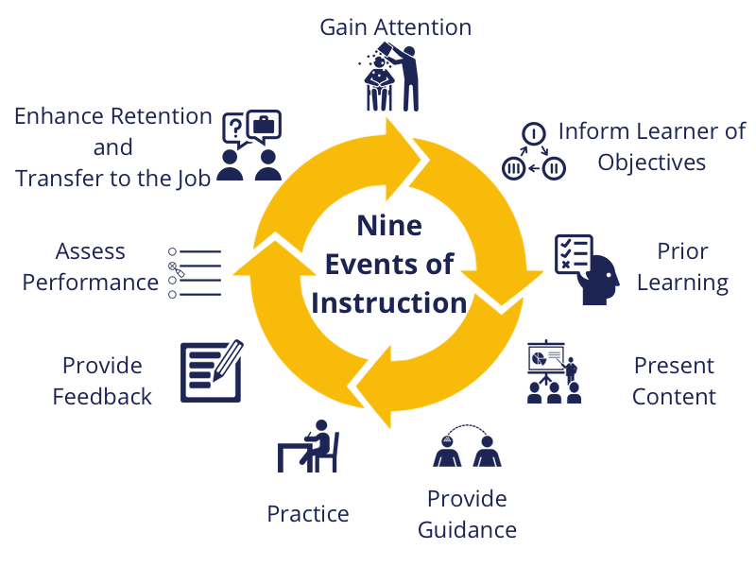

Strategies
- Gain Attention & Motivate the Learner
- Inform the learner of the outcomes/Explain What is to be Learned
- Recall Previous Knowledge/ Prior Learning
- Present the Material to be Learned
- Provide Guidance for Learning
- Active Involvement/ Practice and Interactive with Content
- Provide Feedback ( Formative)
- Assessment Performance ( Summative)
- Provide Enrichment, Enhance Retention, Transfer of Responsibility

