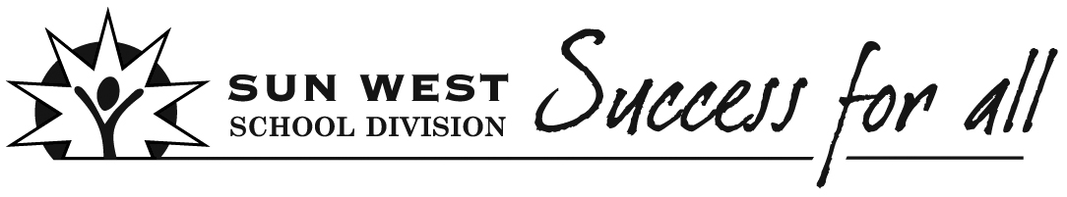
Learning Experiences (Unit) Planning
Teacher(s) | Subject(s) |  | Grade |  | Date  Timeline
Big Ideas/Key Questions/Essential Understandings
Create a Big Idea to guide the Learning Experience
I do | We do | You do
Teacher looks at outcomes and decides the Big Idea for the Learning Experience. | Teacher and students work together to come up with the Big Idea. | Teacher provides students with outcomes and students come up with the Big Idea.
Big Idea(s)

Outcomes
I do | We do | You do
Teachers use the Curriculum document to select specific outcomes that address the Learning Experience. | Teachers and students look at the Curriculum outcomes or I can statements together and select specific outcomes that address the Learning Experience. | Teacher shows students the curriculum outcomes or I can statements and students lead the way in deciding the specific outcomes that address the Learning Experience.
(Consider unpacking some of the outcomes with your students.)
Selected Outcomes

Assessment Plan
I do | We do | You do
Teacher creates and/or determines which assessment tools are appropriate for the Learning Experience. | Teachers and students create and/or determine which assessment tools are appropriate for the Learning Experience. | Students create and/or determine which assessment tools are appropriate for the Learning Experience.

Pre-Assessment Plan | Formative Assessment Plan |  |  | Summative Assessment Plan
Instructional Strategies/Activities
Plan learning activities and lessons that align and support Big Ideas and selected outcomes while honouring student learning profiles.
I do | We do | You do
Teacher creates and/or determines learning activities and lessons. | Teachers and students create and/or determine learning activities and lessons. | Students create and/or determine learning activities.
Chosen instructional strategies/activities

Ways to differentiate to meet individual student's needs

Opportunities for Personalization
Examples:
- Student Voice and Choice
- Technology
- Resources

Materials/Resources/FNMI
I do | We do | You do
Teacher determines the materials and resources that address the Big Ideas, outcomes, and Learning Experience. | Teacher and students determine the materials and resources that address the Big Ideas, outcomes, and Learning Experience. | Students determine the materials and resources that address the Big Ideas, outcomes, and Learning Experience.
Selected Materials/Resources/FNMI

7 C’s  Consider how to incorporate:  - Creativity, Innovation and Entrepreneurship  - Critical Thinking  - Collaboration  - Communication  - Character  - Cultural and Ethical Citizenship  - Computer and Digital Technologies (Learning Tools) |  | REORDER  Consider how to incorporate:  - Relationships  - Environment  - Opportunities  - Resources  - Distribution of Leadership  - Evaluation  - Recognition
Reflection

