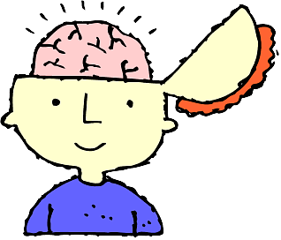
Put Your Brains TOGETHER
Four students per group; 4 minutes per student
SPEAKER (2 min)
- Topic
- Why you chose it.
- The 3 or more resources you used.
- What you have learned along the way.
- Three BIG IDEAS or 3 “take aways” from your learning.
- What would you do differently
- How can others get started learning about this?
- Anything else?
GROUP (2 min)
- Give your feedback (1 positive; 1 wish/idea)
- Help them “fill in” any missing parts from the 8 questions above!

The Rules
BE KIND
BE CONSTRUCTIVE
SELF MANAGE!

