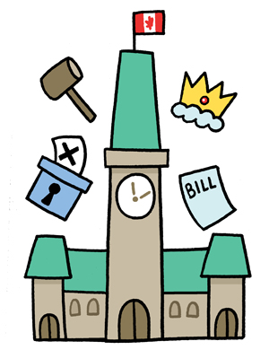
Canadian Government
Scavenger Hunt!

Group Members: _____________________________________________
Kinds of Government – page 80-82
- Canada’s government can be described as FOUR different kinds of government listed on these pages (democracy, constitutional, parliamentary, monarchy). Match the name of the type of government to the description below by writing the name in the blank.

__________________ a monarch (king, queen, emperor, sultan) are in charge and rule everything

__________________ people vote their leaders in and they represent them. The people have the power

__________________ this is sometimes called a cabinet government, a prime minister and cabinet ministers (other members of parliament) run the show

__________________ a set of laws that state the rights and freedoms of the people that live there (the citizens)
Page 81(use the internet to find the names)
- The Head of State is the ________________________ .
- The Head of Government is the ___________________________ .
- The Governor General represents the _________________ but is picked (appointed) by the ________________________. What kind of government would you NOT want to live in? _______________ Why? ___________________________________________________
Page 82
- Without Canada’s ___________________ there would be no laws or order to protect people and their property. The make ______________ and _________________ for the people that break them.
- In Canada we have THREE different branches of government. Write the proper name on the line beside the description.
_____________________ Make laws and pass legislation (rules).
_____________________ Put laws into effect.
_____________________ Decide if laws are broken and the punishment for breaking them.
Page 83
- The word “Sovereign” on the chart just means the _________________.
Page 84 – The Governor General
- Who was our first Canadian Governor General? _________________
- Where have you heard that name before? _____________________
- Who does the Governor General Represent? ___________________
- Who picks or appoints the Governor General? ___________________
- The Governor General serves as a reminder of the ______________.
- The Current Governor General’s name is ______________________
- Put a picture of him here:

- The current name of the Queen is _______________________.
- Put a picture of her here:

Page 85 – The Prime Minister
- He/she is the head of ____________________________.
- He/she is the leader of the ______________ with the most seats in
the House of Commons.
Our current Prime Minister is _________________________ he belongs to the ___________________ party.
- Put a current picture of him here:

Page 86-87 – The Cabinet
- Who picks the cabinet ministers? _____________________
- How many cabinet ministers are there? _________________
The cabinet is powerful and important because they are the real _________________________ of the country. They decide polices and make decisions.
- Three examples of Cabinet Minister Jobs are: __________________,
______________________, _________________________

Page 88 – Our Parliament – Federal (The COUNTRY of Canada)
- Complete the chart.

Represented by
Parliament

Government leader

Lower Chamber
_________________________(other name)
-About 300 seats
-elected Members of Parliament voted in by the people
Upper Chamber
___________(other name)
-About 100 seats
-Picked or appointed by PM

Page 124 – Provincial Government (Province)
- Complete the Chart.

Picked by Governor General & the PM says who
Leader

Cabinet & Members of the Provincial Parliament (MPPs) elected by the people of the province.

Our current Premier is ___________________
Put a picture of our current provincial government leader here:

Page 125 – Municipal Government (City or Town)
- What are the names of the people elected to these positions?
________________
- Who is the leader of this group of people? ________________
- What is the name of this person for Brandon? __________________
- Put a picture of her here:

Page 72-74 + Any others in package!
- Complete the chart. This is the really important stuff!
Level of Government | Area they are in charge of (List 3) | Leader’s Title | Current Leader’s Name

Page 114-117 – Elections
- When people vote we call it an _______________
- The leader of the party with the most elected seats (Members of
Parliament) in the House of Common becomes the _______________
- Do we elect a Member of Parliament (MP) or a Prime Minister (PM) in
Canada? ___________________
- To vote you must be ________________ and a _______________.
- Can prisoners vote? _______
- If you live in Canada but are out of the country during the election can
you vote? ______
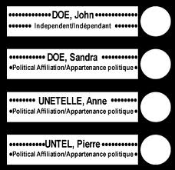
- What is the paper called that you vote on? _________
- Can someone watch you vote? ________
- Show how we mark a ballot here.

Show a teacher ALL of your groups completed scavenger hunts! Hand in ONE copy.
Teacher Initials

